# III. System Requirement Specification

## 1. Overall Description

### 1.1 Product Overview

#### Unauthenticated User Requirements

Unauthenticated user who has not been identified by CFFE system. Unauthenticated user has limited access to the system with the following feature:

* Login by account

#### Authenticated User Requirements

Authenticated User who has been logged into the CFFE system. Authenticated user can use the following functions:

* Logout
* Get own profile
* Update own profile
* Get the report
* Download the report
* Get the video
* Get the products
* Get product detail
* Get the categories
* Get category detail
* Get the cameras
* Get camera detail

#### Manager Requirements

Manager is a person who accesses to the system as manager role. Manager can use the following functions:

* Get the shelves
* Get shelf detail
* Update the shelf
* Delete the shelf
* Create the shelf
* Get the stacks
* Get stack detail
* Update the stack
* Delete the stack
* Create the stack
* Upload the videos

#### Admin Requirements

Admin is a person who accesses to the system as admin role. Admin can use the following functions:

* Get the stores
* Get store detail
* Update the store
* Delete the store
* Create the store
* Get the managers
* Get manager detail
* Update the manager
* Reset account's password
* Delete the manager
* Create the manager
* Create new account
* Update the product
* Delete the product
* Create new product
* Update the camera
* Delete the camera
* Create new camera
* Update the category
* Delete the category
* Create new category

#### System AI Requirements

System AI is an actor which can do:

* Analyze facial expression
* Count the customers

### 1.2 Business Rules

|  |  |
| --- | --- |
| ID | Rule Definition |
| BR-001 | User logs in CFFE system by username and password are registered. If the username and password are correct, CFFE system redirects users to "Dash board" page. |
| BR-002 | After successful login, the system will automatically generate a token and send it to the client. The client will save in local storage and cookies. |
| BR-003 | When changing the manager status to inactive, there must be a reason and sure that this store is removed from the manager. |
| BR-004 | After logging out successfully, user becomes the “Unauthenticated User” and CFFE system will redirect to login page. |
| BR-005 | Information on local storage will be removed on the client-side. |
| BR-006 | Cookies will be destroyed on the client-side. |
| BR-007 | The password must be SHA256 encrypted before sending it to the server. |
| BR-008 | After resting account's password or creating account successfully, CFFE system sends an email for the manager that includes:   * Username * Password |
| BR-009 | Stack's status has three options:   * Active (active and has added the camera and the product) * Pending (active but has not added the product or camera) * Inactive (inactive) |
| BR-010 | CFFE system only allows users to play video that has been analyzed and stored. |
| BR-011 | Displays a list of videos with the following information:   * Store * Shelf (Counting type) * Video name * Start time * End time * Upload time * Analyzed result |
| BR-012 | Password must be at least 8 characters and contain the following:   * At least one uppercase letter * At least one lowercase letter * At least one digits |
| BR-013 | User can search the categories with following conditions:   * Category name * Status (Category’s status includes all statuses, active, and inactive) * Status's default value is all statuses. |
| BR-014 | Shelf select box can select multiple values that include:   * All shelves * Specific shelves (including active, pending, and inactive shelves that sort by shelf's name)   Default value is all shelves. |
| BR-015 | Displays a list of managers with the following information:   * No * Username * Full name * Store * Updated Time * Status |
| BR-016 | Product select box can select multiple values that include:   * All products * Specific products (including active, and inactive products that sort by product's name   Default value is all products |
| BR-017 | Admin can search the manager with following conditions:   * Search text * Option (Option includes Full name, User name) * Status (Manager’s status includes all statuses, active, pending, and inactive)   Option's default value is username  Status's default value is all status. |
| BR-018 | Analyzed options checkbox can select single values that include:   * Counting * Emotion   Default value is emotion and counting. |
| BR-019 | Video uploading is mp4 format and their name must follow the pattern:  [Camera type]_[MAC address]_[File order]  In there:   * Value of camera type is 1: counting or 2: emotion. * MAC address is for the added cameras on the shelves or stacks. |
| BR-020 | Duplicate videos could not be uploaded by checking video name, video creation date, and checking in Database. |
| BR-021 | User can search the videos with following conditions:   * Start Date * End Date * Video type: counting/emotion * Store * Shelf * Product   Start Date and End Date's default interval value is 10 days from the current date.  Store's default value is all stores.  Shelf's default value is all shelves.  Product's default value is the first value.  Video type's default value is counting.  If counting checkbox is chosen, shelf field is hidden. Else if emotion checkbox is chosen,  product field is hidden.  If user is a manager, the store will be specifically assigned the managing store and hide the store field. |
| BR-022 | Managers can only view the camera in the store they are managing and the camera has pending and inactive status. |
| BR-023 | Displays the user detail with the following information:   * Full name * Email * Gender Birthday * Phone * Identity Card * Username * Store |
| BR-024 | The shelf can add maximum of two cameras. |
| BR-025 | After creating a successful shelf, the stacks will automatically create based on the number of stacks. |
| BR-026 | Manager can search the shelves with following conditions:   * Shelf name * Status (Shelf’s status includes all status, active, and inactive)   Status's default value is all status. |
| BR-027 | Displays a list of shelves with the following information:   * No * Shelf name * Description * Number of stacks * Updated time * Status |
| BR-028 | Displays the shelf detail with the following information:   * Shelf name * Description * Number of stacks * Created * Updated time * Reason inactive * Status * Camera Added * List of stacks * Stack detail |
| BR-029 | If the pending camera is used by any shelf or stack, the camera's status will change to active automatically.  If the active camera is removed from any shelf or stack, the camera's status will change to pending automatically. |
| BR-030 | When changing the shelf's status to inactive, there must be a reason and sure that all the stacks are inactive and all cameras on the shelf are removed. |
| BR-031 | A shelf information required fields:   * Name: between 1 - 100 characters, unique in a store * Description: between 1 - 250 characters * Number of stacks: between 1 - 30 stacks * Status: active/pending/inactive |
| BR-032 | After updating or deleting, CFFE system updates the Updated Time. |
| BR-033 | Deletion is a change to inactive status |
| BR-034 | Manager's status has three options:   * Active (Manager is active and is managing a store) * Pending (Manager is active and isn't managing a store) * Inactive (Manager is inactive) |
| BR-035 | After creation, CFFE system stores the create time. |
| BR-036 | The product must be added before the camera can be added to the stack. Conversely, camera removal is required before the product is removed from the stack. |
| BR-037 | * Displays a list of stacks with the following information: * No * Product * Camera * Status |
| BR-038 | * Displays the stack detail with the following information: * No * Product added * Camera added * Created Time * Updated Time * Reason inactive * Status |
| BR-039 | Manager only can select a pending camera, product to set up on the shelf, stack. |
| BR-040 | * Only stores and managers with pending status can be selected for manager and store management. |
| BR-041 | When changing the stack status from pending to inactive, there must be a reason and sure that the product and camera on the stack are removed. |
| BR-042 | If the product and camera are already on the stack, the stack's status will change to active automatically. If the product or camera on the stack is missed, the status will change to pending automatically. |
| BR-043 | A new account will be generated by the following method:   * Username: [Manager's first name] + [First letter of manager's last name] + [Sequence number]. * Password: automatically generate. |
| BR-044 | User can search the products with following conditions:   * Product name * Product category * Status (Product’s status includes all statuses, active, and inactive)   Product category's default value is all categories.  Status's default value is all statuses. |
| BR-045 | * Displays a list of products with the following information: * No * Product name * Product image * Description * Category * Updated time * Status |
| BR-046 | * Displays the product detail with the following information: * Product name * Product image * Category * Description * List of stores * List of stacks * Created * Updated time * Reason inactive * Status |
| BR-047 | * A product information required fields: * Product name: between 1 - 100 characters, unique * Image: must be png, jpg, jpeg format * Category: 1 - 3 categories * Description: between 1 - 250 characters * Status: active/inactive |
| BR-048 | * Shelf's status has three options: * Active (active and has added one or two cameras) * Pending (active but has not added the camera) * Inactive (inactive) |
| BR-049 | When changing the product status to inactive, there must be a reason and sure that this product on all stacks is removed. |
| BR-050 | Stack's No is the position on the shelf that is automatically generated by the CFFE system in the order of creation. |
| BR-051 | If the camera is already on the shelf, the shelf's status will change to active automatically.  If the camera on the shelf is missed, the shelf's status will change to pending automatically. |
| BR-052 | User can search the cameras with following conditions:   * Camera name * Store * Status (Camera’s status includes all status, active, pending, and inactive)   Store's default value is all stores  Status's default value is all status. |
| BR-053 | * Displays a list of cameras with the following information: * No * Camera name * Camera image * Store * MAC Address * Updated Time * Status |
| BR-054 | * Displays the camera detail with the following information: * Camera name * Camera image * Ip address * RTSP string * Shelf * Stack * Created * Updated time * Reason inactive * Status |
| BR-055 | * A camera information required fields: * Camera name: between 1 - 100 characters, unique * Image: must be png, jpg, jpeg format * IP address: x.x.x.x (x is number between 0 to 255), unique * MAC address: hexadecimal separated by "-", unique * RTSP string: at least 1 character, unique * Status: active/pending/inactive |
| BR-056 | * Camera status has three options: * Active (active and has added on a shelf or stack) * Pending (active but has not added on a shelf or stack) * Inactive (inactive) |
| BR-057 | When changing the category status to inactive, make sure that all products that have this category remove mapping. |
| BR-058 | When changing the camera status to inactive, there must be a reason and sure that this camera are removed from the shelf or stack. |
| BR-059 | Store's status has three options:   * Active (active and had added the manager) * Pending (active but hadn't added the manager) * Inactive (inactive) |
| BR-060 | A user information required fields:   * Full name: between 1 - 100 characters * Username: between 1 - 30 characters * Image: must be png, jpg, jpeg format + Gender: Male/Female * Birthday: must be dd:mm:yyyy * Identity card: between 9 - 12 digits * Phone: between 10 - 13 digits * Email: must match /^(([^<>()[\]\\.,;:\s@"]+(\.[^<>()[\]\\.,;:\s@"]+)*)|(".+"))@((\[[0-9]{1,3}\.[0-9]{1,3}\.[0-9]{1,3}\.[0-9]{1,3}\])|(([a-zA-Z\-0-9]+\.)+[a-zA-Z]{2,}))$/ regex * Address: between 1 - 250 characters + City + District * Status: active/pending/inactive |
| BR-061 | * Displays the store detail with the following information: * Full name * Username * Avatar * Gender * Birthday * Identity Card * Phone * Email * Store * Address * City * District * Created Time * Updated time * Reason inactive * Status |
| BR-062 | * Displays the category detail with the following information: * Category name * Products belongs to the category |
| BR-063 | * A category information required fields: * Category name: between 1 - 100 characters, unique |
| BR-064 | * Admin can search the stores with following conditions: * Store name * City * Status (Store’s status includes all status, active and inactive) * Status's default value is all status. * City's default value is all cities. |
| BR-065 | * Displays a list of stores with the following information: * No * Store name * Image * Manager * Address * District * City * Updated Time * Status |
| BR-066 | * Displays the store detail with the following information: * Store name * Image * Manager * Address * City * District * Product list * Camera list * Created * Updated time * Reason inactive * Status |
| BR-067 | * A store information required fields: * Store name: between 1 - 100 characters, unique * Image: must be png, jpg, jpeg format * Address: between 1 - 250 characters * City: 1 city * District: 1 district * Status: active/pending/inactive |
| BR-068 | * When granting store management rights to the manager, the status of the store and manager will automatically change to active. * When removing the manager from the store, the status of the store and manager will automatically change to pending. |
| BR-069 | When changing the store status to inactive, there must be a reason and sure that this manager is removed from the store and all shelves of this store are inactive. |
| BR-070 | After creating, the objects have the following status:   * Store: Pending * Manager: Pending * Camera: Pending * Shelf: Pending * Stack: Pending * Product: Active * Category: Active |

*Table 1 - Business rules*

## 2. User Requirements

### 2.1 Overview

#### Use Case Diagram

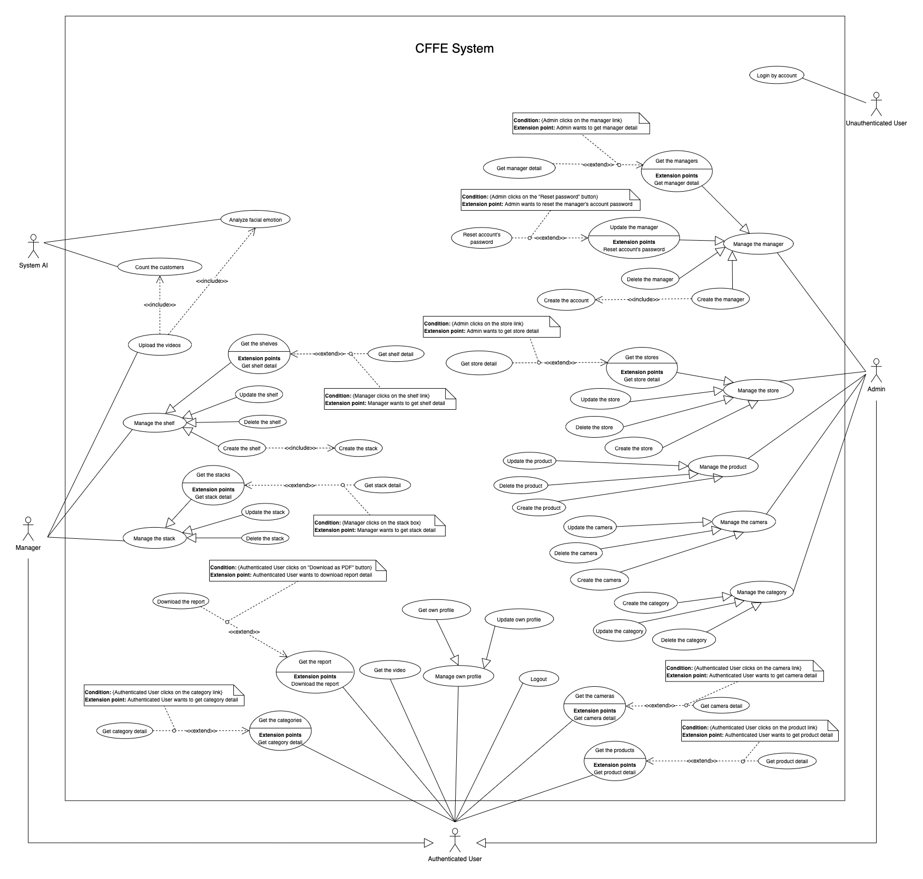

*Figure 1 - <Use Case Overview> Overview*

#### System Actors

|  |  |  |
| --- | --- | --- |
| **#** | **Actor** | **Description** |
| 1 | Unauthenticated User | Unauthenticated User is person who has no account. |
| 2 | Authenticated User | Authenticated User is a person who has an account in the system (There are two roles that are admin and manager). |
| 3 | Manager | Manager manages the store's products, shelves, stacks, and cameras. |
| 4 | Admin | Admin manages the managers, accounts, and stores in the system. |
| 5 | System AI | System AI analyses customers' emotions and count the customers in the stores. |

*Table 2 - System actors*

#### Use Case List

|  |  |  |  |
| --- | --- | --- | --- |
| **ID** | **Use Case** | **Primary Actors** | **Secondary Actors** |
| UC-01 | **Login by account** | Unauthenticated User | N/A |
| UC-02 | **Logout** | Authenticated User | N/A |
| UC-03 | **Get own profile** | Authenticated User |  |
| UC-04 | **Update own profile** | Authenticated User | N/A |
| UC-05 | **Get the report** | Authenticated User | N/A |
| UC-06 | **Download the report** | Authenticated User | N/A |
| UC-07 | **Get the video** | Authenticated User | ~~N/A~~ |
| UC-08 | **Get the products** | Authenticated User | N/A |
| UC-09 | **Get product detail** | Authenticated User | N/A |
| UC-10 | **Get the categories** | Authenticated User | N/A |
| UC-11 | **Get category detail** | Authenticated User | N/A |
| UC-12 | **Get the cameras** | Authenticated User | N/A |
| UC-13 | **Get camera detail** | Authenticated User | N/A |
| UC-14 | **Get the shelves** | Manager | N/A |
| UC-15 | **Get shelf detail** | Manager | N/A |
| UC-16 | **Update the shelf** | Manager | N/A |
| UC-17 | **Delete the shelf** | Manager | N/A |
| UC-18 | **Create the shelf** | Manager | N/A |
| UC-19 | **Get the stacks** | Manager | N/A |
| UC-20 | **Get stack detail** | Manager | N/A |
| UC-21 | **Update the stack** | Manager | N/A |
| UC-22 | **Delete the stack** | Manager | N/A |
| UC-23 | **Create the stack** | Manager | N/A |
| UC-24 | **Upload the videos** | Manager | N/A |
| UC-25 | **Get the stores** | Admin | N/A |
| UC-26 | **Get store detail** | Admin | N/A |
| UC-27 | **Update the store** | Admin | N/A |
| UC-28 | **Delete the store** | Admin | N/A |
| UC-29 | **Create the store** | Admin | N/A |
| UC-30 | **Get the managers** | Admin | N/A |
| UC-31 | **Get manager detail** | Admin | N/A |
| UC-32 | **Update the manager** | Admin | N/A |
| UC-33 | **Reset account's password** | Admin | N/A |
| UC-34 | **Delete the manager** | Admin | N/A |
| UC-35 | **Create the manager** | Admin | N/A |
| UC-36 | **Create new account** | Admin | N/A |
| UC-37 | **Update the product** | Admin | N/A |
| UC-38 | **Delete the product** | Admin | N/A |
| UC-39 | **Create new product** | Admin | N/A |
| UC-40 | **Update the camera** | Admin | N/A |
| UC-41 | **Delete the camera** | Admin | N/A |
| UC-42 | **Create new camera** | Admin | N/A |
| UC-43 | **Update the category** | Admin | N/A |
| UC-44 | **Delete the category** | Admin | N/A |
| UC-45 | **Create new category** | Admin | N/A |
| UC-46 | **Analyze facial emotion** | System AI | N/A |
| UC-47 | **Count the customers** | System AI | N/A |

*Table 3 - Use case list*

### User case specification



#### 2.2.1 <Unauthenticated User> Overview Use Case

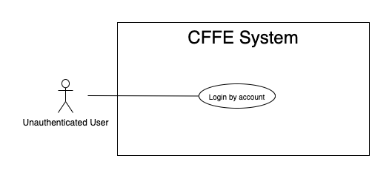

*Figure 2 - <Overview Use Case> Unauthenticated User*

##### 2.2.1.1 <Unauthenticated User> Login by account



*Figure 3 - <Use Case> Login by account*

|  |  |  |  |
| --- | --- | --- | --- |
| ID and Name: | **UC-01 Login by account** | | |
| Created By: | TruongTN | Date Created: | 25/06/2021 |
| Primary Actor: | Unauthenticated User | Secondary Actors: | N/A |
| Description: | This feature allows the unauthenticated user to login to CFFE system to verify the role and gives them access to more features. | | |
| Trigger: | Unauthenticated User sends a request to login to CFFE system. | | |
| Pre-conditions: | PRE-01. User's account has been created.  PRE-02. User's account has been authorized as Admin or Manager role.  PRE-03. User has not logged in to CFFE system. | | |
| Post-conditions: | POST-01:   * Success: User logins to CFFE system with his/her role successfully and redirect to "Dashboard" page. * Fail: CFFE system shows error message. | | |
| Normal Flow: | **1.0 Login by account**   1. Unauthenticated User send a request to login to the CFFE system. 2. CFFE system requires information from Unauthenticated User:  * “Username”: input text * “Password”: input text * “Login”: button  1. Unauthenticated User inputs a login form: username, password. 2. Unauthenticated User clicks to “Login” button. 3. CFFE system validates the username and password. (Exception 1.0.E1, 1.0.E2) 4. CFFE system determines the user’s identity, role, and permission then redirects to the "Dashboard" page. | | |
| Alternative Flows: | N/A | | |
| Exceptions: | **1.0.E1 Unauthenticated User does not enter the required fields**   1. CFFE system returns to Unauthenticated User to fill the required fields again (MSG-001, MSG-002). 2. If Unauthenticated User inputs the required fields again, CFFE system returns to step 3 of the normal flow. 3. Else if Unauthenticated User cancels the login process, then CFFE system terminates this use case.   **1.0.E2 Unauthenticated User enters wrong username or password.**   1. CFFE system returns to Unauthenticated User to fill the required fields again (MSG-003). 2. If Unauthenticated User inputs username and password again, CFFE system returns to step 3 of the normal flow. 3. Else if Unauthenticated User cancels the login process, then CFFE system terminates this use case. | | |
| Priority: | High | | |
| Frequency of Use: | Always | | |
| Business Rules: | BR-001, BR-002, BR-007 | | |
| Other Information: | In case of internet connection failure, Unauthenticated User cannot finish this use case. | | |
| Assumptions: | N/A | | |

*Table 4 - <Use Case> Login by account*

#### 2.2.2 <Authenticated User> Overview Use Case

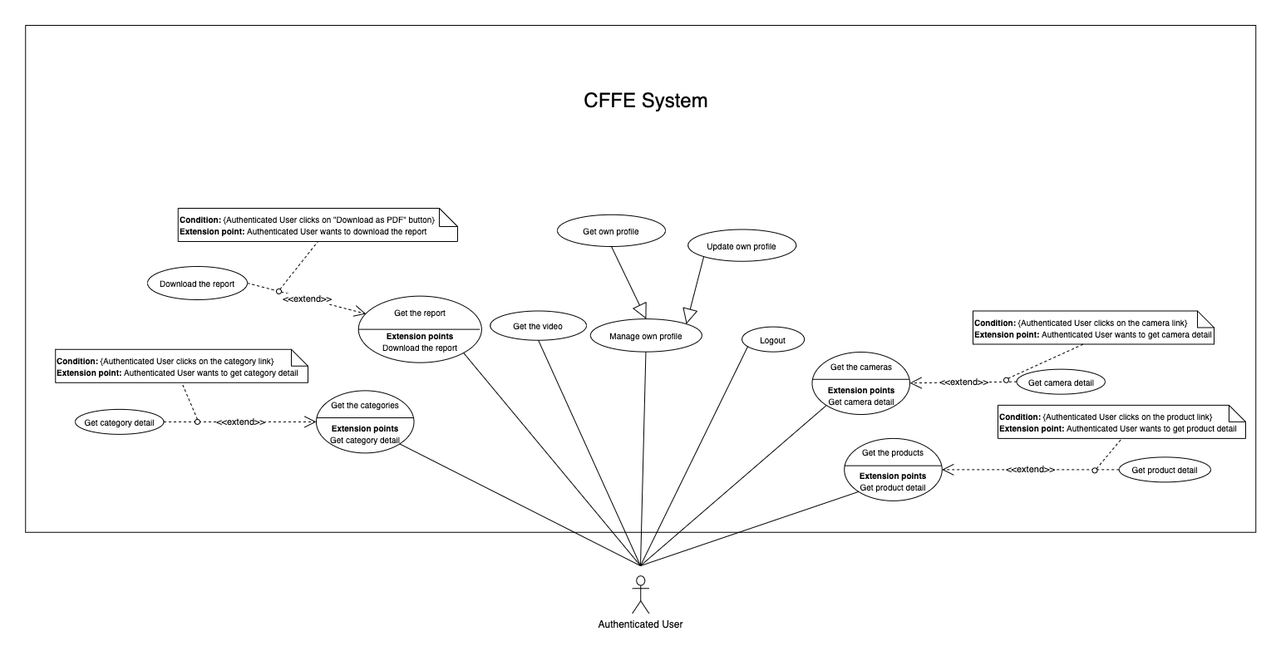

*Figure 4 - <Overview Use Case> Authenticated User*

##### 2.2.2.1 <Authenticated User> Logout

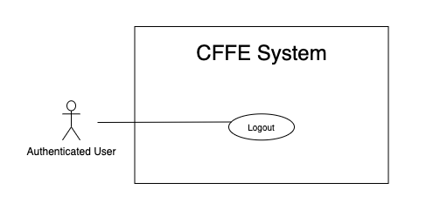

*Figure 5 - <Use Case> Logout*

|  |  |  |  |
| --- | --- | --- | --- |
| ID and Name: | **UC-02 Logout** | | |
| Created By: | TruongTN | Date Created: | 25/06/2021 |
| Primary Actor: | Authenticated User | Secondary Actors: | N/A |
| Description: | This feature allows the authenticated user to log out from CFFE system. | | |
| Trigger: | Authenticated user sends a request to log out from CFFE system. | | |
| Pre-conditions: | PRE-01. User has logged into CFFE system. | | |
| Post-conditions: | POST-01. User has successfully logged out CFFE system. | | |
| Normal Flow: | **2.0 Logout**   1. Authenticated user focus on username then clicks on “Logout” button of the navigation bar. 2. CFFE system deletes information on their local storage and cookie. 3. CFFE system redirects to "Login" page. | | |
| Alternative Flows: | N/A | | |
| Exceptions: | N/A | | |
| Priority: | Medium | | |
| Frequency of Use: | Usually | | |
| Business Rules: | BR-004, BR-005, BR-006 | | |
| Other Information: | In case of internet connection failure, Authenticated User cannot finish this use case. | | |
| Assumptions: | N/A | | |

*Table 5 - <Use Case> Logout*

##### 2.2.2.2 <Authenticated User> Get own profile

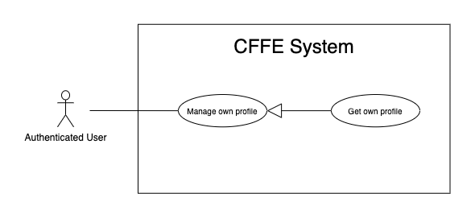

*Figure 43 - <Use Case> Get own profile*

|  |  |  |  |
| --- | --- | --- | --- |
| ID and Name: | **UC-03 Get own profile** | | |
| Created By: | HuuDN | Date Created: | 17/06/2021 |
| Primary Actor: | Authenticated User | Secondary Actors: | N/A |
| Description: | This feature allows the authenticated user to get his/her profile. | | |
| Trigger: | Authenticated User sends a request to get his/her profile. | | |
| Preconditions: | PRE-01. User has logged into CFFE system. | | |
| Post-conditions: | POST-01:   * Success: CFFE system redirects to his/her profile page. * Fail: CFFE system shows error message. | | |
| Normal Flow: | **3.0 Get own profile**   1. Authenticated User focus on username then clicks on "Profile" button of the navigation bar. 2. CFFE system returns his/her information and redirects to profile page. (Exception 3.0.E1) | | |
| Alternative Flows: | N/A | | |
| Exceptions: | **3.0.E1 Authenticated User does not exist.**  1. CFFE system returns the message (MSG-041) and terminates this use case. | | |
| Priority: | Normal | | |
| Frequency of Use: | Sometime | | |
| Business Rules: | N/A | | |
| Other Information: | In case of internet connection failure, Authenticated User cannot finish this use case properly. | | |
| Assumptions: | N/A | | |

*Table 42 - <Use Case> Get own profile*

##### 2.2.2.3 <Authenticated User> Update own profile

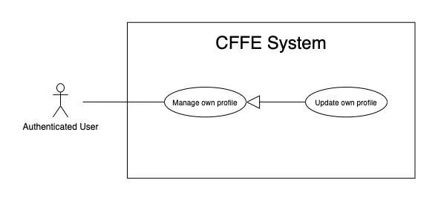

*Figure 44 - <Use Case> Update own profile*

|  |  |  |  |
| --- | --- | --- | --- |
| ID and Name: | **UC-04 Update own profile** | | |
| Created By: | HuuDN | Date Created: | 17/06/2021 |
| Primary Actor: | Authenticated User | Secondary Actors: | N/A |
| Description: | This feature allows the authenticated user to update his/her profile. | | |
| Trigger: | Authenticated User sends a request to update his/her profile. | | |
| Preconditions: | PRE-01. User has logged in CFFE system.  PRE-02. User is on “Profile” page. | | |
| Post-conditions: | POST-01:   * Success: CFFE system shows success message and reloads "Profile" page. * Fail: CFFE system shows error message. | | |
| Normal Flow: | **4.0 Update information** (Alternative 4.0, 4.1)   1. Authenticated User clicks on "Edit Information" button. 2. CFFE system requires store information that includes:  * “Full name”: input text * “Gender”: radio button * “Birthday”: date picker * “Identity card”: input text * “Phone number”: input text * “Email”: input text * “Address”: input text * “City”: select box * “District”: select box * “Cancel”: button * “Update”: button  1. Authenticated User inputs/selects the required fields. 2. Authenticated User clicks on “Update” button. (Alternative 4.2) 3. CFFE system validates the fields (Exception 4.0.E1, 4.0.E2) 4. CFFE system updates his/her information and returns the success message (MSG-013). | | |
| Alternative Flows: | **4.0 Update Avatar**   1. Authenticated User clicks on "Update avatar" button. 2. CFFE system shows popup that includes:    * "Avatar": label    * "Choose": button    * "OK": button    * "Cancel": button 3. Authenticated User clicks on "Choose" button and selects an image. 4. Authenticated User clicks on "OK" button. (Alternative 4.2, 4.3) 5. CFFE system validates the image (Exception 4.0.E3, 4.0.E4, 4.0.E7) 6. CFFE system updates his/her avatar and returns the success message (MSG-013).   **4.1 Update password**   1. Authenticated User clicks on "Change password" button. 2. CFFE system shows popup that includes:    * "Old password": input text    * "New password": input text    * "Retype password": input text    * "OK": button    * "Cancel": button 3. Authenticated User inputs all fields. 4. Authenticated User clicks on "OK" button. (Alternative 4.2, 4.3) 5. CFFE system validates the image (Exception 4.0.E5, 4.0.E6) 6. CFFE system updates his/her password and returns the success message (MSG-013).   **4.2 Authenticated User cancels the updating process.**   1. Authenticated User clicks on "Cancel" button. 2. CFFE system closes this popup and terminates this use case.   **4.3 Authenticated User clicks outside of popup.**   1. Authenticated User clicks outside of popup. 2. CFFE system closes this popup and terminates this use case. | | |
| Exceptions: | **4.0.E1 Authenticated User does not input/select the required fields**   1. CFFE system returns to Authenticated User to input/select the required fields again (MSG-014, MSG-036, MSG-038, MSG-039, MSG-049, MSG-044, MSG-047, MSG-051, MSG-054). 2. If Authenticated User inputs/selects the required fields again, CFFE system returns to step 3 of the normal flow. 3. Else if Authenticated User cancels the updating process, then CFFE system terminates this use case.   **4.0.E2 Authenticated User inputs/selects the fields that are not valid**   1. CFFE system returns to Authenticated Users to input/select the fields again (MSG-015, MSG-037, MSG-042, MSG-045, MSG-052, MSG-073). 2. If Authenticated User inputs/selects the fields again, CFFE system returns to step 3 of the normal flow. 3. Else if Authenticated User cancels the updating process, then CFFE system terminates this use case.   **4.0.E3 Authenticated User does not select an image**   1. CFFE system returns to Authenticated User to select the required fields again (MSG-112). 2. If Authenticated User inputs/selects the required fields again, CFFE system returns to step 3 of the alternative flow 4.0. 3. Else if Authenticated User cancels the updating process, then CFFE system terminates this use case.   **4.0.E4 Image is not png/jpg/jpeg format.**   1. CFFE system shows message (MSG-027) and terminates this use case.   **4.0.E5 Authenticated User does not input the required fields**   1. CFFE system returns to Authenticated User to input/select the required fields again (MSG-004, MSG-005, MSG-006). 2. If Authenticated User inputs/selects the required fields again, CFFE system returns to step 3 of the alternative flow 4.1. 3. Else if Authenticated User cancels the updating process, then CFFE system terminates this use case.   **4.0.E6 Authenticated User inputs the fields that are not valid**   1. CFFE system returns to Authenticated Users to input/select the fields again (MSG-007, MSG-008, MSG-068). 2. If Authenticated User inputs/selects the fields again, CFFE system returns to step 3 of the alternative flow 4.1. 3. Else if Authenticated User cancels the updating process, then CFFE system terminates this use case.   **4.0.E7 CFFE system cannot upload the image.**   1. CFFE system shows error message (MSG-114) and terminates this use case. | | |
| Priority: | Medium | | |
| Frequency of Use: | Often | | |
| Business Rules: | BR-032, BR-034, BR-060 | | |
| Other Information: | In case of internet connection failure, Authenticated User cannot finish this use case properly. | | |
| Assumptions: | N/A | | |

*Table 37 - <Use Case> Update own profile*

##### 2.2.2.4 <Authenticated User> Get the report

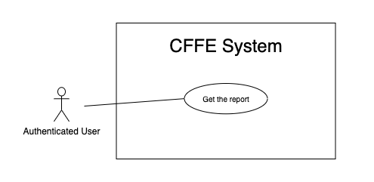

*Figure 7 - <Use Case> Get the report*

|  |  |  |  |
| --- | --- | --- | --- |
| ID and Name: | **UC-05 Get the report** | | |
| Created By: | HuuDN | Date Created: | 15/06/2021 |
| Primary Actor: | Authenticated User | Secondary Actors: | N/A |
| Description: | This feature allows the Authenticated User to get the report. | | |
| Trigger: | Authenticated User sends a request to get the report. | | |
| Preconditions: | PRE-01. User has logged into CFFE system as admin or manager role. | | |
| Post-conditions: | POST-01. Authenticated User has successfully got the report. | | |
| Normal Flow: | **5.0 Get the facial expression analysis report** (Alternative 5.0)   1. Authenticated User clicks on "Dashboard" button on the navigation bar. 2. CFFE system requires the report's information from Authenticated User:  * “Product name”: select box * “Store name”: select box * “Date rage”: date range picker  1. Authenticated User selects all fields. 2. CFFE system returns the reports (Exception 5.0.E1). | | |
| Alternative Flows: | **5.0 Get the counting customer report**   1. Authenticated User clicks on "Dashboard" button on the navigation bar. 2. Authenticated User clicks on "Counting customer" button on the left-bottom navigation bar of the frame. 3. CFFE system requires the report's information from Authenticated User:  * “Store name”: select box * “Shelf name”: select box * “Date rage”: date range picker  1. Authenticated User selects all fields. 2. CFFE system returns the reports (Exception 5.0.E1). | | |
| Exceptions: | **5.0.E1 The report has no data.**   1. CFFE system returns the message (MSG-009). | | |
| Priority: | High | | |
| Frequency of Use: | Often | | |
| Business Rules: | BR-013, BR-014, BR-016 | | |
| Other Information: | In case of internet connection failure, Authenticated User cannot finish this use case properly. | | |
| Assumptions: | N/A | | |

*Table 7 - <Use Case> Get the report*

##### 2.2.2.5 <Authenticated User> Download the report

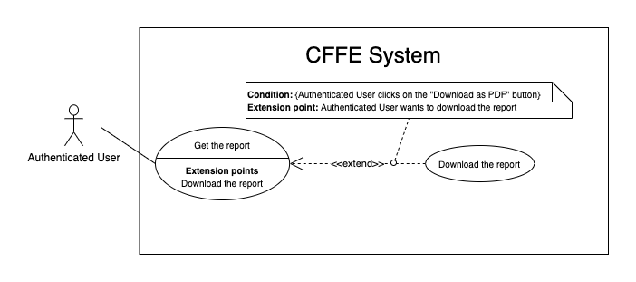

*Figure 8 - <Use Case> Download the report*

|  |  |  |  |
| --- | --- | --- | --- |
| ID and Name: | **UC-06 Download the report** | | |
| Created By: | HuuDN | Date Created: | 18/06/2021 |
| Primary Actor: | Authenticated User | Secondary Actors: | N/A |
| Description: | This feature allows Authenticated User to download the report. | | |
| Trigger: | Authenticated User sends a request to download the report. | | |
| Preconditions: | PRE-01. User has logged into CFFE system as admin or manager role.  PRE-02. Authenticated User on "Dashboard" page. | | |
| Post-conditions: | POST-01. Authenticated User has successfully downloaded the report. | | |
| Normal Flow: | **6.0 Download the report**   1. Authenticated User right clicks on "Dashboard" page. 2. Authenticated User clicks on "Download as PDF" 3. CFFE system shows the popup that includes:    * "All pages": radio button    * "Select pages": radio button    * "Additional Options": dropdown list      + "Ignore custom background color": check box      + "Add a link back to report": check box      + "Password protect report": check box    * "Download": button    * "Cancel": button 4. Authenticated User selects that fields 5. Authenticated User clicks on "Download" button. (Alternative 6.0, 6.1) 6. CFFE system downloads this report on client-side. | | |
| Alternative Flows: | **6.0 Authenticated User cancels the downloading process.**   1. Authenticated User clicks on "Cancel" button. 2. CFFE system closes this popup and terminates this use case.   **6.1 Authenticated User clicks outside of popup.**   1. Authenticated User clicks outside of popup. 2. CFFE system closes this popup and terminates this use case. | | |
| Exceptions: | N/A | | |
| Priority: | High | | |
| Frequency of Use: | Often | | |
| Business Rules: | BR-008, BR-009. | | |
| Other Information: | In case of internet connection failure, Authenticated User cannot finish this use case properly. | | |
| Assumptions: | N/A | | |

*Table 8 - <Use Case> Download the report*

##### 2.2.2.6 <Authenticated User> Get the video

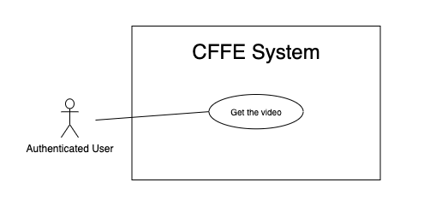

*Figure 9 - <Use Case> Get the video*

|  |  |  |  |
| --- | --- | --- | --- |
| ID and Name: | **UC-07 Get the video** | | |
| Created By: | HuuDN | Date Created: | 11/06/2021 |
| Primary Actor: | Authenticated User | Secondary Actors: | N/A |
| Description: | This feature allows Authenticated User to get the video. | | |
| Trigger: | Authenticated User sends a request to get the video. | | |
| Preconditions: | PRE-01. User has logged into CFFE system as admin or manager role. | | |
| Post-conditions: | POST-01. Authenticated User has successfully got the video. | | |
| Normal Flow: | **7.0 Get the video**   1. Authenticated User clicks on "Video" button on the navigation bar. 2. CFFE system requires the video's information from Authenticated User:  * “Start Date”: text input * “End Date”: text input * “Counting”: check box * “Emotion”: check box * “Store”: select box * “Shelf”: select box * “Product”: select box  1. Authenticated User inputs/selects the fields. 2. CFFE system returns the corresponding videos (Exception 7.0.E1). | | |
| Alternative Flows: | N/A | | |
| Exceptions: | **7.0.E1 The video list has no data.**   1. CFFE system returns the message (MSG-009). | | |
| Priority: | High | | |
| Frequency of Use: | Often | | |
| Business Rules: | BR-010, BR-011, BR-021 | | |
| Other Information: | In case of internet connection failure, Authenticated User cannot finish this use case properly. | | |
| Assumptions: | N/A | | |

*Table 9 - <Use Case> Get the video*

##### 2.2.3.7 <Authenticated User> Get the products

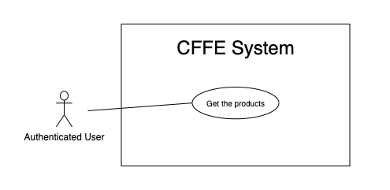

*Figure 22 - <Use Case> Get the products*

|  |  |  |  |
| --- | --- | --- | --- |
| ID and Name: | **UC-08 Get the products** | | |
| Created By: | HieuNT | Date Created: | 08/05/2021 |
| Primary Actor: | Authenticated User | Secondary Actors: | N/A |
| Description: | This feature allows authenticated user to get the products. | | |
| Trigger: | Authenticated user sends a request to get the products. | | |
| Pre-conditions: | PRE-01. User has logged into the system as admin or manager role. | | |
| Post-conditions: | POST-01. CFFE system returns the list of products. | | |
| Normal Flow: | **8.0 Get the products**   1. Authenticated User clicks on "Product" button on the navigation bar. 2. CFFE system requires the product information:  * “Product name”: input text * “Category”: select box * “Status”: select box  1. Authenticated user inputs/selects the fields: product name, category, status. 2. CFFE system returns the list of products based on below conditions and display them (Exception 8.0.E1). | | |
| Alternative Flows: | N/A | | |
| Exceptions: | **8.0.E1 The list of product has no data.**   1. CFFE system returns the message (MSG-009). | | |
| Priority: | High | | |
| Frequency of Use: | Usually | | |
| Business Rules: | BR-044, BR-045 | | |
| Other Information: | In case of internet connection failure, authenticated user cannot finish this use case properly. | | |
| Assumptions: | N/A | | |

*Table 21 - <Use Case> Get the products*

##### 2.2.3.8 <Authenticated User> Get product detail

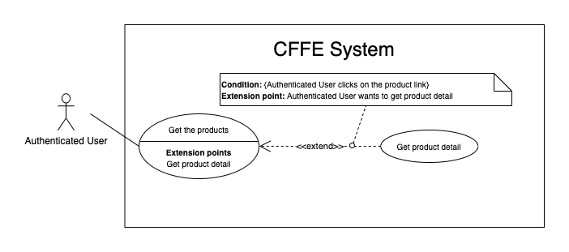

*Figure 23 - <Use Case> Get product detail*

|  |  |  |  |
| --- | --- | --- | --- |
| ID and Name: | **UC-09 Get product detail** | | |
| Created By: | HieuNT | Date Created: | 10/05/2021 |
| Primary Actor: | Authenticated User | Secondary Actors: | N/A |
| Description: | This feature allows the authenticated user to getproductdetail. | | |
| Trigger: | Authenticated user sends a request to get product detail. | | |
| Preconditions: | PRE-01. User has logged in the system as admin or manager role.  PRE-02. There is at least one product link. | | |
| Post-conditions: | POST-01:   * Success: CFFE system redirects to "Product Detail" page. * Fail: CFFE system shows error message. | | |
| Normal Flow: | **9.0 Get product detail**   1. Authenticated user clicks on the product link. 2. CFFE system validates the product exists (Exception 19.0.E1) 3. CFFE system returns the product information and redirects to product detail page. | | |
| Alternative Flows: | N/A | | |
| Exceptions: | **9.0.E1 The product does not exist.**  1. CFFE system returns the message (MSG-023) and terminates this use case. | | |
| Priority: | High | | |
| Frequency of Use: | Usually | | |
| Business Rules: | BR-046 | | |
| Other Information: | In case of internet connection failure, Authenticated user cannot finish this use case properly. | | |
| Assumptions: | N/A | | |

*Table 22 - <Use Case> Get product detail*

##### 2.2.3.9 <Authenticated User> Get the categories

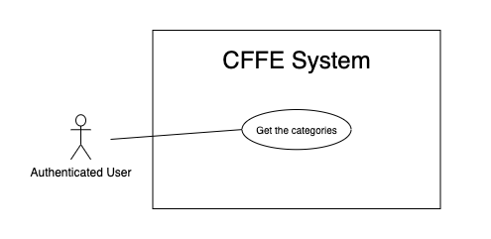

*Figure 32 - <Use Case> Get the categories*

|  |  |  |  |
| --- | --- | --- | --- |
| ID and Name: | **UC-10 Get the categories** | | |
| Created By: | TruongTN | Date Created: | 08/05/2021 |
| Primary Actor: | Authenticated user | Secondary Actors: | N/A |
| Description: | This feature allows manager to get the categories. | | |
| Trigger: | Authenticated user sends a request to get the categories. | | |
| Pre-conditions: | PRE-01. User has logged into the system as admin or manager role. | | |
| Post-conditions: | POST-01. CFFE system returns the list of categories. | | |
| Normal Flow: | **10.0 Get the categories**   1. Authenticated user clicks on "Category" button on the navigation bar. 2. CFFE system requires the camera information:  * “Category name”: input text * “Status”: select box  1. Authenticated user inputs/selects the fields: category name 2. CFFE system returns the list of products based on below conditions and display them (Exception 10.0.E1). | | |
| Alternative Flows: | N/A | | |
| Exceptions: | **10.0.E1 The list of categories has no data.**   1. CFFE system returns the message (MSG-009). | | |
| Priority: | High | | |
| Frequency of Use: | Usually | | |
| Business Rules: | BR-013, BR-062 | | |
| Other Information: | In case of internet connection failure, authenticated user cannot finish this use case properly. | | |
| Assumptions: | N/A | | |

*Table 31 - <Use Case> Get the categories*

##### 2.2.3.10 <Authenticated User> Get category detail

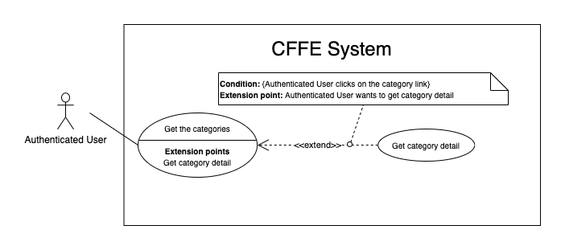

*Figure 33 - <Use Case> Get category detail*

|  |  |  |  |
| --- | --- | --- | --- |
| ID and Name: | **UC-11 Get category detail** | | |
| Created By: | HuuDN | Date Created: | 10/05/2021 |
| Primary Actor: | Authenticated User | Secondary Actors: | N/A |
| Description: | This feature allows the authenticated user to getcategorydetail. | | |
| Trigger: | Authenticated user sends a request to get categorydetail. | | |
| Preconditions: | PRE-01. User has logged in the system as admin or manager role.  PRE-02. User is on "Category" page. | | |
| Post-conditions: | POST-01:   * Success: CFFE system returns category detail successfully. * Fail: CFFE system shows error message. | | |
| Normal Flow: | **11.0 Get category detail**   1. Authenticated user clicks on the category button of the left-side list. 2. CFFE system validates the categoryexists (Exception 11.0.E1) 3. CFFE system returns the categoryinformation. | | |
| Alternative Flows: | N/A | | |
| Exceptions: | **11.0.E1 The category does not exist.**  1. CFFE system returns the message (MSG-029) and terminates this use case.  **11.0.E2 The list of products that belong to this category has no data.**  1. CFFE system returns the message (MSG-009). | | |
| Priority: | High | | |
| Frequency of Use: | Usually | | |
| Business Rules: | BR-062 | | |
| Other Information: | In case of internet connection failure, Authenticated User cannot finish this use case properly. | | |
| Assumptions: | N/A | | |

*Table 32 - <Use Case> Get category detail*

##### 2.2.3.11 <Authenticated User> Get the cameras

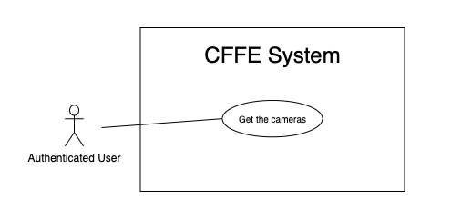

*Figure 27 - <Use Case> Get the cameras*

|  |  |  |  |
| --- | --- | --- | --- |
| ID and Name: | **UC-12 Get the cameras** | | |
| Created By: | HuuDN | Date Created: | 08/05/2021 |
| Primary Actor: | Authenticated user | Secondary Actors: | N/A |
| Description: | This feature allows authenticated user to get the cameras. | | |
| Trigger: | Authenticated user sends a request to get the cameras. | | |
| Pre-conditions: | PRE-01. User has logged into the system as admin or manager role. | | |
| Post-conditions: | POST-01. CFFE system returns the list of cameras. | | |
| Normal Flow: | **12.0 Get the cameras**   1. Authenticated user clicks on "Camera" button on the navigation bar. 2. CFFE system requires the camera information:  * “Camera name”: input text * “Store”: select box * “Status”: select box  1. Authenticated user inputs/selects the fields. 2. CFFE system returns the list of products based on below conditions and display them (Exception 12.0.E1). | | |
| Alternative Flows: | N/A | | |
| Exceptions: | **12.0.E1 The list of cameras has no data.**   1. CFFE system returns the message (MSG-009). | | |
| Priority: | High | | |
| Frequency of Use: | Usually | | |
| Business Rules: | BR-052, BR-053, BR-056 | | |
| Other Information: | In case of internet connection failure, authenticated user cannot finish this use case properly. | | |
| Assumptions: | N/A | | |

*Table 26 - <Use Case> Get the cameras*

##### 2.2.3.11 <Authenticated User> Get camera detail

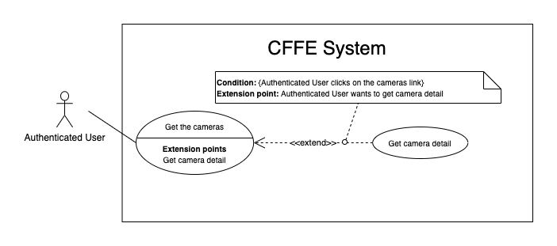

*Figure 28 - <Use Case> Get camera detail*

|  |  |  |  |
| --- | --- | --- | --- |
| ID and Name: | **UC-13 Get camera detail** | | |
| Created By: | HuuDN | Date Created: | 10/05/2021 |
| Primary Actor: | Authenticated User | Secondary Actors: | N/A |
| Description: | This feature allows the authenticated user to getcameradetail. | | |
| Trigger: | Authenticated User sends a request to get camera detail. | | |
| Preconditions: | PRE-01. User has logged in the system as admin or manager role.  PRE-02. There is at least one camera link. | | |
| Post-conditions: | POST-01:   * Success: CFFE system returns camera detail successfully and redirects to "Camera Detail" page. * Fail: CFFE system shows error message. | | |
| Normal Flow: | **13.0 Get camera detail**   1. Authenticated User clicks on the camera link. 2. CFFE system validates the camera exists (Exception 13.0.E1, 13.1.E1). 3. CFFE system returns the camera information and redirects to camera detail page. | | |
| Alternative Flows: | N/A | | |
| Exceptions: | **13.0.E1 The camera does not exist.**  1. CFFE system returns the message (MSG-009) and terminates this use case.  **13.1.E1 The camera access is not allowed.**  1. CFFE system returns the message (MSG-120) and terminates this use case. | | |
| Priority: | High | | |
| Frequency of Use: | Usually | | |
| Business Rules: | BR-022, BR-054, BR-056 | | |
| Other Information: | In case of internet connection failure, Authenticated User cannot finish this use case properly. | | |
| Assumptions: | N/A | | |

*Table 27 - <Use Case> Get camera detail*

#### 2.2.3 <Manager> Overview Use Case

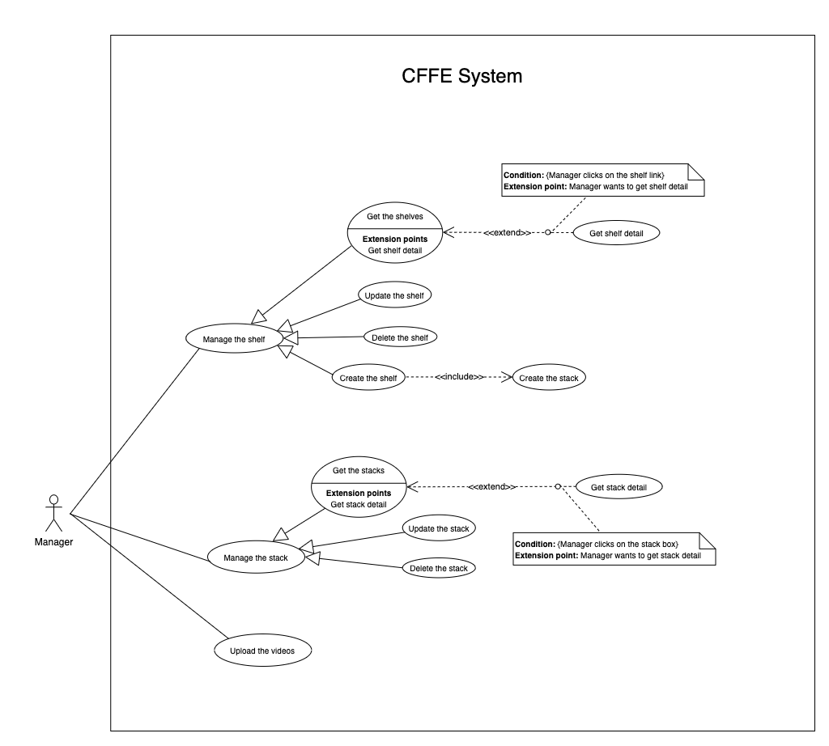

*Figure 11 - <Overview Use Case> Manager*

##### 2.2.3.1 <Manager> Get the shelves

##### 

*Figure 12 - <Use Case> Get the shelves*

|  |  |  |  |
| --- | --- | --- | --- |
| ID and Name: | **UC-14 Get the shelves** | | |
| Created By: | TruongTN | Date Created: | 08/05/2021 |
| Primary Actor: | Manager | Secondary Actors: | N/A |
| Description: | This feature allows the manager to get the shelves. | | |
| Trigger: | Manager sends a request to get the shelves. | | |
| Pre-conditions: | PRE-01. User has logged into the system as manager role.  PRE-02. Manager is managing a store. | | |
| Post-conditions: | POST-01. CFFE system returns the list of shelves. | | |
| Normal Flow: | **14.0 Get the shelves**   1. Manager clicks on "Shelf" button on the navigation bar. 2. CFFE system requires the shelf information from Manager:  * “Shelf name”: input text * “Status”: select box  1. Manager inputs/selects the fields. 2. CFFE system returns the shelves based on below conditions and display them (Exception 14.0.E1). | | |
| Alternative Flows: | N/A | | |
| Exceptions: | **14.0.E1 The list of shelves has no data.**   1. CFFE system returns the message (MSG-009). | | |
| Priority: | High | | |
| Frequency of Use: | Usually | | |
| Business Rules: | BR-026, BR-027, BR-048 | | |
| Other Information: | In case of internet connection failure, Manager cannot finish this use case properly. | | |
| Assumptions: | N/A | | |

*Table 11 - <Use Case> Get the shelves*

##### 2.2.3.2 <Manager> Get shelf detail

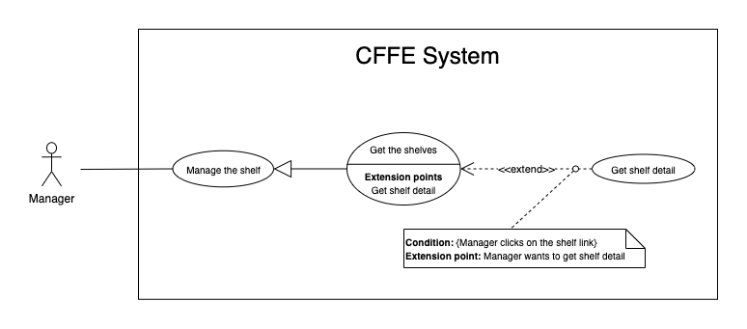

*Figure 13 - <Use Case> Get shelf detail*

|  |  |  |  |
| --- | --- | --- | --- |
| ID and Name: | **UC-15 Get shelf detail** | | |
| Created By: | TruongTN | Date Created: | 10/05/2021 |
| Primary Actor: | Manager | Secondary Actors: | N/A |
| Description: | This feature allows the Manager to get shelf detail. | | |
| Trigger: | Manager sends a request to get shelf detail. | | |
| Preconditions: | PRE-01. User has logged in the system as manager role.  PRE-02. There is at least one shelf link. | | |
| Post-conditions: | POST-01:   * Success: CFFE system returns shelf detail successfully and redirects to "Shelf Detail" page. * Fail: CFFE system shows error message. | | |
| Normal Flow: | **15.0 Get shelf detail**   1. Manager clicks on the shelf link. 2. CFFE system validates the shelf exists (Exception 15.0.E1) 3. CFFE system returns the shelf information and redirects to shelf detail page. | | |
| Alternative Flows: | N/A | | |
| Exceptions: | **15.0.E1 The shelf does not exist.**  1. CFFE system returns the message (MSG-009) and terminates this use case. | | |
| Priority: | High | | |
| Frequency of Use: | Usually | | |
| Business Rules: | BR-028, BR-048 | | |
| Other Information: | In case of internet connection failure, Manager cannot finish this use case properly. | | |
| Assumptions: | N/A | | |

*Table 12 - <Use Case> Get shelf detail*

##### 2.2.3.3 <Manager> Update the shelf

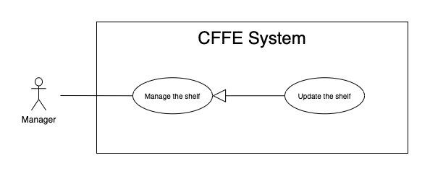

*Figure 14 - <Use Case> Update the shelf*

|  |  |  |  |
| --- | --- | --- | --- |
| ID and Name: | **UC-16 Update the shelf** | | |
| Created By: | TruongTN | Date Created: | 18/06/2021 |
| Primary Actor: | Manager | Secondary Actors: | N/A |
| Description: | This feature allows Manager to update shelf in CFFE system. | | |
| Trigger: | Manager sends a request to update the shelf. | | |
| Preconditions: | PRE-01. User has logged in the system as manager role.  PRE-02. Manager is on “Shelf detail” page. | | |
| Post-conditions: | POST-01:   * Success: CFFE system shows success message and reloads "Shelf Detail" page. * Fail: CFFE system shows error message. | | |
| Normal Flow: | **16.0 Update the shelf information** (Alternative 16.0, 16.1, 16.2)   1. Manager clicks on "Edit Information" button on the Shelf box. 2. CFFE system requires shelf information that includes:  * “Shelf name”: input text * “Description”: input text * “Update”: button * “Cancel”: button  1. Manager inputs the required fields. 2. Manager clicks on “Update” button. (Alternative 16.3) 3. CFFE system validates the required fields (Exception 16.0.E1, 16.0.E2) 4. CFFE system updates shelf information and returns the success message (MSG-013). | | |
| Alternative Flows: | **16.0 Adding the camera to the shelf**   1. Manager clicks on "Add camera" button on the camera box. 2. CFFE system shows popup that includes:    * "Camera": list box    * "OK": button    * "Cancel": button 3. Manager clicks on the Camera box. 4. Manager clicks on "OK" button. (Alternative 16.3, 16.4) 5. CFFE system validates the chosen camera and shelf. (Exception 16.0.E3, 16.0.E4, 16.0.E5) 6. CFFE system adds the camera to the shelf and returns the success message (MSG-013).   **16.1 Removing the camera from the shelf**   1. Manager clicks on "Remove camera" button on the camera box. 2. CFFE system shows confirm popup with message "Do you want to remove this camera from this shelf?" and two buttons for Manager selecting:    * "OK" button    * "Cancel" button 3. Manager clicks on "OK" button. (Alternative 16.3, 16.4) 4. CFFE system validates the camera and shelf. (Exception 16.0.E6) 5. CFFE system remove the camera from the shelf and returns the success message (MSG-013).   **16.2 Reactivate the inactive shelf.**   1. Manager focus on "Inactive" button then clicks on "Pending" button. 2. CFFE system shows confirm popup with message "Do you want to active this shelf?" and two buttons for Manager select:    * "OK" button    * "Cancel" button 3. Manager clicks on "OK" button. (Alternative 16.3, 16.4) 4. CFFE system validates the shelf. (Exception 16.0.E7) 5. CFFE system updates the shelf's status and returns the success message (MSG-013).   **16.3 Manager cancels the updating process.**   1. Manager clicks on "Cancel" button. 2. CFFE system closes this popup and terminates this use case.   **16.4 Manager clicks outside of popup.**   1. Manager clicks outside of popup. 2. CFFE system closes this popup and terminates this use case. | | |
| Exceptions: | **16.0.E1 Manager does not input the required fields**   1. CFFE system returns to Manager to fill the required fields again (MSG-079, MSG-016). 2. If Manager inputs the required fields again, CFFE system returns to step 3 of the normal flow. 3. Else if Manager cancels the updating process, then CFFE system terminates this use case.   **16.0.E2 Manager inputs the required fields that are not valid**   1. CFFE system returns to Manager to fill the required fields again (MSG-080, MSG-017). 2. If Manager inputs the required fields again, CFFE system returns to step 3 of the normal flow. 3. Else if Manager cancels the updating process, then CFFE system terminates this use case.   **16.0.E3 Shelf does not exist or is active.**   1. CFFE system returns error message (MSG-085) and terminates this use case.   **16.0.E4 Camera does not exist or is active.**   1. CFFE system returns the error message (MSG-086) and terminates this use case.   **16.0.E5 Shelf does not exist.**   1. CFFE system returns the error message (MSG-012) and terminates this use case.   **16.0.E6 Camera on the shelf is full.**   1. CFFE system returns the error message (MSG-128) and terminates this use case.   **16.0.E7 Camera is not on the shelf.**   1. CFFE system returns the error message (MSG-088) and terminates this use case. | | |
| Priority: | High | | |
| Frequency of Use: | Usually | | |
| Business Rules: | BR-024, BR-031, BR-032, BR-039, BR-048, BR-051 | | |
| Other Information: | In case of internet connection failure, Manager cannot finish this use case properly. | | |
| Assumptions: | N/A | | |

*Table 13 - <Use Case> Update the shelf*

##### 2.2.3.4 <Manager> Delete the shelf

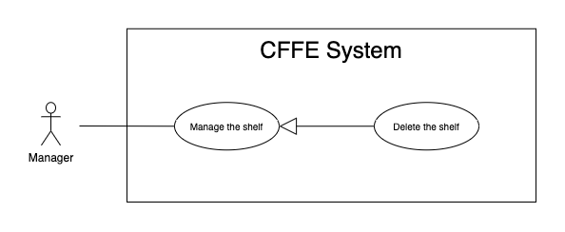

*Figure 15 - <Use Case> Delete the shelf*

|  |  |  |  |
| --- | --- | --- | --- |
| ID and Name: | **UC-17 Delete the shelf** | | |
| Created By: | TruongTN | Date Created: | 18/06/2021 |
| Primary Actor: | Manager | Secondary Actors: | N/A |
| Description: | This feature allows Manager to delete the shelf. | | |
| Trigger: | Manager sends a request to delete the shelf. | | |
| Preconditions: | PRE-01. User has logged in the system as manager role.  PRE-02. Manager is on “Shelf detail” page. | | |
| Post-conditions: | POST-01:   * Success: CFFE system shows success message and reloads "Shelf Detail" page. * Fail: CFFE system shows error message. | | |
| Normal Flow: | **17.0 Delete the shelf**   1. Manager focus on "Pending" button then clicks on "Inactive" button. 2. CFFE system shows delete popup with message: "Do you want to inactive this shelf?" and required form:  * "Inactive reason": text area * "OK": button * "Cancel": button  1. Manager inputs the field. 2. Manager clicks on "OK" button. (Alternative 17.0, 17.1) 3. CFFE system validates the required field and the shelf. (Exception 17.0.E1, 17.0.E2, 17.0.E3) 4. CFFE system updates the shelf's status and returns the success message (MSG-040). | | |
| Alternative Flows: | **17.0 Manager cancels the deleting process.**   1. Manager clicks on "Cancel" button. 2. CFFE system closes this popup and terminates this use case.   **17.1 Manager clicks outside of popup.**   1. Manager clicks outside of popup. 2. CFFE system closes this popup and terminates this use case. | | |
| Exceptions: | **17.0.E1 The shelf does not exist**   1. CFFE system returns error message (MSG-012) and terminates this use case.   **17.0.E2 Manager does not input the inactive reason and remove all stacks, cameras.**   1. CFFE system returns error message (MSG-066) and terminates this use case.   **17.0.E3 Manager inputs the inactive reason fields that are not valid**   1. CFFE system returns error message (MSG-067) and terminates this use case. | | |
| Priority: | Medium | | |
| Frequency of Use: | Often | | |
| Business Rules: | BR-030, BR-032, BR-033, BR-048 | | |
| Other Information: | In case of internet connection failure, Manager cannot finish this use case properly. | | |
| Assumptions: | N/A | | |

*Table 14 - <Use Case> Delete the shelf*

##### 2.2.3.5 <Manager> Create the shelf

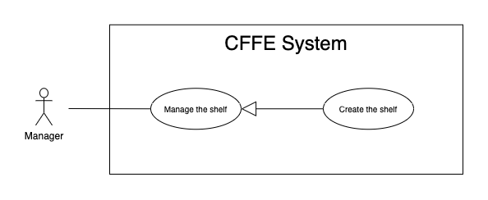

*Figure 16 - <Use Case> Create the shelf*

|  |  |  |  |
| --- | --- | --- | --- |
| ID and Name: | **UC-18 Create the shelf** | | |
| Created By: | TruongTN | Date Created: | 10/05/2021 |
| Primary Actor: | Manager | Secondary Actors: | N/A |
| Description: | This feature allows Manager to create the shelf. | | |
| Trigger: | Manager sends a request to create the shelf. | | |
| Preconditions: | PRE-01. User has logged in the system as manager role.  PRE-02. Manager is on “Manage Shelf” page. | | |
| Post-conditions: | POST-01:   * Success: CFFE system shows success message and reloads "Shelf" page. * Fail: CFFE system shows error message. | | |
| Normal Flow: | **18.0 Create the** **shelf**   1. Manager clicks on "New" button. 2. CFFE system shows the popup that includes:  * “Shelf name”: input text * “Description”: input text * “Number of stacks”: input text * “Create”: button * “Cancel”: button  1. Manager inputs the required fields. 2. Manager clicks on “Create” button. (Alternative 18.0, 18.1) 3. CFFE system validates the required fields. (Exception 18.0.E1, 18.0.E2) 4. CFFE system creates newly shelf and returns the success message (MSG-011). | | |
| Alternative Flows: | **18.0 Manager cancels the creating process.**   1. Manager clicks on "Cancel" button. 2. CFFE system closes this popup and terminates this use case.   **18.1 Manager clicks outside of popup.**   1. Manager clicks outside of popup. 2. CFFE system closes this popup and terminates this use case. | | |
| Exceptions: | **18.0.E1 Manager does not input the required fields**   1. CFFE system returns to Manager to fill the required fields again (MSG-079, MSG-016). 2. If Manager inputs the required fields again, CFFE system returns to step 3 of the normal flow. 3. Else if Manager cancels the creating process, then CFFE system terminates this use case.   **18.0.E2 Manager inputs the required fields that are not valid**   1. CFFE system returns to Manager to fill the required fields again (MSG-080, MSG-017, MSG-019). 2. If Manager inputs the required fields again, CFFE system returns to step 3 of the normal flow. 3. Else if Manager cancels the creating process, then CFFE system terminates this use case. | | |
| Priority: | Medium | | |
| Frequency of Use: | Often | | |
| Business Rules: | BR-025, BR-031, BR-035, BR-048, BR-070 | | |
| Other Information: | In case of internet connection failure, Manager cannot finish this use case properly. | | |
| Assumptions: | N/A | | |

*Table 15 - <Use Case> Create the shelf*

##### 2.2.3.6 <Manager> Get the stacks

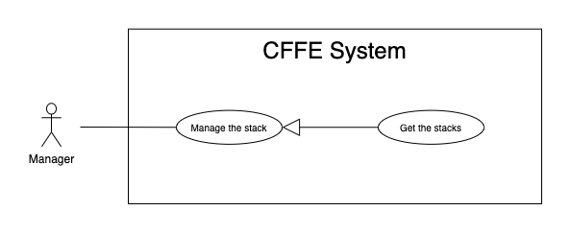

*Figure 17 - <Use Case> Get the stacks*

|  |  |  |  |
| --- | --- | --- | --- |
| ID and Name: | **UC19- Get the stacks** | | |
| Created By: | LuanNM | Date Created: | 08/05/2021 |
| Primary Actor: | Manager | Secondary Actors: | N/A |
| Description: | This feature allows manager to get the stacks. | | |
| Trigger: | Manager sends a request to get the stacks. | | |
| Pre-conditions: | PRE-01. User has logged into the system as manager role.  PRE-02. Manager is managing a store.  PRE-03. There is at least one shelf link. | | |
| Post-conditions: | POST-01. CFFE system returns the list of stacks. | | |
| Normal Flow: | **19.0 Get the stacks**   1. Manager clicks on the shelf link. 2. CFFE system validates the shelf exists (Exception 19.0.E1, 19.0.E2) 3. CFFE system returns the stack list and redirects to shelf detail page. | | |
| Alternative Flows: | N/A | | |
| Exceptions: | **19.0.E1 The shelf does not exist.**  1. CFFE system returns the message (MSG-009) and terminates this use case.  **19.0.E2 The list of stacks has no data.**   1. CFFE system returns the message (MSG-009) and terminates this use case. | | |
| Priority: | High | | |
| Frequency of Use: | Usually | | |
| Business Rules: | BR-009, BR-037 | | |
| Other Information: | In case of internet connection failure, Manager cannot finish this use case properly. | | |
| Assumptions: | N/A | | |

*Table 16 - <Use Case> Get the stacks*

##### 2.2.3.7 <Manager> Get stack detail

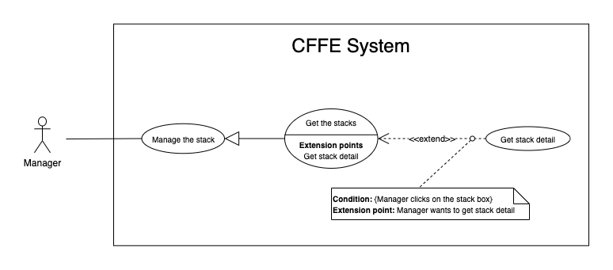

*Figure 18 - <Use Case> Get stack detail*

|  |  |  |  |
| --- | --- | --- | --- |
| ID and Name: | **UC-20 Get stack detail** | | |
| Created By: | LuanNM | Date Created: | 10/05/2021 |
| Primary Actor: | Manager | Secondary Actors: | N/A |
| Description: | This feature allows the Manager to getstackdetail. | | |
| Trigger: | Manager sends a request to get stack detail. | | |
| Preconditions: | PRE-01. User has logged in the system as manager role.  PRE-02. Manager is on "Shelf Detail" page. | | |
| Post-conditions: | POST-01. CFFE system returns stack information. | | |
| Normal Flow: | **20.0 Get stack detail**   1. Manager clicks on the stack box. 2. CFFE system validates the stack exists (Exception 20.0.E1) 3. CFFE system returns the stack information and displays it. | | |
| Alternative Flows: | N/A | | |
| Exceptions: | **20.0.E1 The stack does not exist.**  1. CFFE system returns the message (MSG-022) and terminates this use case. | | |
| Priority: | High | | |
| Frequency of Use: | Usually | | |
| Business Rules: | BR-009, BR-038 | | |
| Other Information: | In case of internet connection failure, Manager cannot finish this use case properly. | | |
| Assumptions: | N/A | | |

*Table 17 - <Use Case> Get stack detail*

##### 2.2.3.8 <Manager> Update the stack

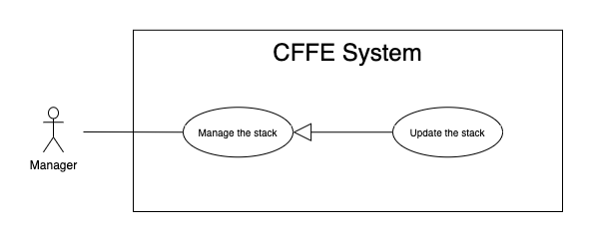

*Figure 19 - <Use Case> Update the stack*

|  |  |  |  |
| --- | --- | --- | --- |
| ID and Name: | **UC-21 Update the stack** | | |
| Created By: | LuanNM | Date Created: | 18/06/2021 |
| Primary Actor: | Manager | Secondary Actors: | N/A |
| Description: | This feature allows Manager to update stack in CFFE system. | | |
| Trigger: | Manager sends a request to update the stack. | | |
| Preconditions: | PRE-01. User has logged in the system as manager role.  PRE-02. Manager is on “Shelf detail” page.  PRE-03. Manager selects a stack. | | |
| Post-conditions: | POST-01:   * Success: CFFE system shows success message and reloads "Shelf Detail" page. * Fail: CFFE system shows error message. | | |
| Normal Flow: | **21.0 Reactive the inactive stack.** (Alternative 21.0, 21.1, 21.2, 21.3)   1. Manager focus on "Inactive" button then clicks on "Pending" button. 2. CFFE system shows confirm popup with message "Do you want to active this stack?" and two buttons for Manager selecting:  * “OK” button * “Cancel” button  1. Manager clicks on "OK" button. (Alternative 21.4, 21.5) 2. CFFE system validates the stack. (Exception 21.0.E1) 3. CFFE system updates stack information and returns the success message (MSG-013). | | |
| Alternative Flows: | **21.0 Adding the product to the stack**   1. Manager clicks on "Add product" button on the product box. 2. CFFE system shows popup that includes:    * "Product": list box    * "OK": button    * "Cancel": button 3. Manager clicks on a Product box. 4. Manager clicks on "OK" button. (Alternative 21.4, 21.5) 5. CFFE system validates the chosen product and stack (Exception 21.0.E1, 21.0.E2, 21.0.E3, 21.0.E4) 6. CFFE system adds the product to the stack and returns the success message (MSG-013).   **21.1 Removing the product from the stack**   1. Manager clicks on "Remove product" button on the product box. 2. CFFE system shows confirm popup with message "Do you want to remove this product from this stack?" and two buttons for Manager selecting:    * "OK" button    * "Cancel" button 3. Manager clicks on "OK" button. (Alternative 21.4, 21.5) 4. CFFE system validates the product and stack. (Exception 21.0.E1, 21.0.E5) 5. CFFE system remove the camera from the shelf and returns the success message (MSG-013).   **21.2 Adding the camera to the stack**   1. Manager clicks on "Add camera" button on the camera box. 2. CFFE system shows popup that includes:    * "Camera": list box    * "OK": button    * "Cancel": button 3. Manager clicks on the Camera box. 4. Manager clicks on "OK" button. (Alternative 21.4, 21.5) 5. CFFE system validates the chosen camera and stack. (Exception 21.0.E1, 21.0.E6, 21.0.E7, 21.0.E8) 6. CFFE system adds the product to the stack and returns the success message (MSG-013).   **21.3 Removing the camera from the stack**   1. Manager clicks on "Remove camera" button on the camera box. 2. CFFE system shows confirm popup with message "Do you want to remove this camera from this stack?" and two buttons for Manager selecting:    * "OK" button    * "Cancel" button 3. Manager clicks on "OK" button. (Alternative 21.4, 21.5) 4. CFFE system validates the camera and stack. (Exception 21.0.E1, 21.0.E9) 5. CFFE system remove the camera from the stack and returns the success message (MSG-013).   **21.4 Manager cancels the updating process.**   1. Manager clicks on "Cancel" button. 2. CFFE system closes this popup and terminates this use case.   **21.5 Manager clicks outside of popup.**   1. Manager clicks outside of popup. 2. CFFE system closes this popup and terminates this use case. | | |
| Exceptions: | **21.0.E1 Stack does not exist.**   1. CFFE system returns error message (MSG-022) and terminates this use case.   **21.0.E2 Product does not exist.**   1. CFFE system returns error message (MSG-023) and terminates this use case.   **21.0.E3 Product is inactive.**   1. CFFE system returns error message (MSG-089) and terminates this use case.   **21.0.E4 Stack already has a product.**   1. CFFE system returns error message (MSG-089) and terminates this use case.   **21.0.E5 Product is not on this stack or Camera is already on this stack.**   1. CFFE system returns error message (MSG-092) and terminates this use case.   **21.0.E6 Camera does not exist.**   1. CFFE system returns error message (MSG-020) and terminates this use case.   **21.0.E7 Camera has active or inactive status.**   1. CFFE system returns error message (MSG-093) and terminates this use case.   **21.0.E8 Stack has not a product.**   1. CFFE system returns error message (MSG-100) and terminates this use case.   **21.0.E9 Camera is not on this stack.**   1. CFFE system returns error message (MSG-094) and terminates this use case. | | |
| Priority: | High | | |
| Frequency of Use: | Often | | |
| Business Rules: | BR-009, BR-029, BR-032, BR-036, BR-039, BR-042 | | |
| Other Information: | In case of internet connection failure, Manager cannot finish this use case properly. | | |
| Assumptions: | N/A | | |

*Table 18 - <Use Case> Update the stack*

##### 2.2.3.9 <Manager> Delete the stack

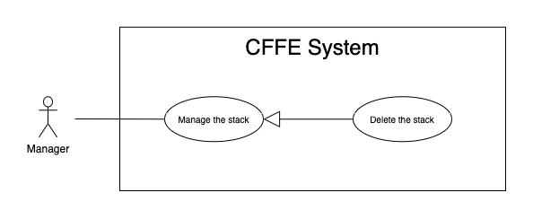

*Figure 20 - <Use Case> Delete the shelf*

|  |  |  |  |
| --- | --- | --- | --- |
| ID and Name: | **UC-22 Delete the stack** | | |
| Created By: | LuanNM | Date Created: | 10/05/2021 |
| Primary Actor: | Manager | Secondary Actors: | N/A |
| Description: | This feature allows Manager to delete the stack. | | |
| Trigger: | Manager sends a request to delete the stack. | | |
| Preconditions: | PRE-01. User has logged in the system as manager role.  PRE-02. Manager is on “Shelf detail” page.  PRE-03. Manager selects a stack. | | |
| Post-conditions: | POST-01:   * Success: CFFE system shows success message and reloads "Shelf Detail" page. * Fail: CFFE system shows error message. | | |
| Normal Flow: | **22.0 Delete the stack**   1. Manager focus on "Pending" button then clicks on "Inactive" button. 2. CFFE system shows delete popup with message: "Do you want to inactive this stack?" and required form:  * "Inactive reason": text area * "OK": button * "Cancel": button  1. Manager inputs the field. 2. Manager clicks on "OK" button. (Alternative 22.0, 22.1) 3. CFFE system validates the required field and the stack. (Exception 22.0.E1, 22.0.E2, 22.0.E3) 4. CFFE system updates the stack's status and returns the success message (MSG-040). | | |
| Alternative Flows: | **22.0 Manager cancels the deleting process.**   1. Manager clicks on "Cancel" button. 2. CFFE system closes this popup and terminates this use case.   **22.1 Manager clicks outside of popup.**   1. Manager clicks outside of popup. 2. CFFE system closes this popup and terminates this use case. | | |
| Exceptions: | **22.0.E1 The stack does not exist**   1. CFFE system returns error message (MSG-022) and terminates this use case.   **22.0.E2 Manager does not input the inactive reason and remove the product.**   1. CFFE system returns error message (MSG-095) and terminates this use case.   **22.0.E3 Manager inputs the inactive reason fields that are not valid**   1. CFFE system returns error message (MSG-067) and terminates this use case. | | |
| Priority: | Medium | | |
| Frequency of Use: | Often | | |
| Business Rules: | BR-009, BR-032, BR-033, BR-041 | | |
| Other Information: | In case of internet connection failure, Manager cannot finish this use case properly. | | |
| Assumptions: | N/A | | |

*Table 19 - <Use Case> Delete the stack*

##### 2.2.3.10 <Manager> Create the stack

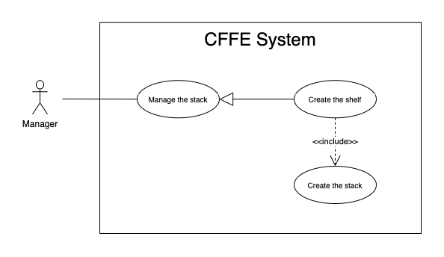

*Figure 21 - <Use Case> Create the stack*

|  |  |  |  |
| --- | --- | --- | --- |
| ID and Name: | **UC-23 Create the stack** | | |
| Created By: | LuanNM | Date Created: | 10/05/2021 |
| Primary Actor: | Manager | Secondary Actors: | N/A |
| Description: | This feature allows Manager to create the stack. | | |
| Trigger: | Manager sends a request to create the stack. | | |
| Preconditions: | PRE-01. User has logged in the system as manager role.  PRE-02. Manager creates the shelf successfully. | | |
| Post-conditions: | POST-01. CFFE system stores newly created stack information. | | |
| Normal Flow: | **23.0 Create the stack**   1. CFFE system creates the stacks based on "number of stacks" of the shelf and returns the success message (Exception 23.0.E1). | | |
| Alternative Flows: | N/A | | |
| Exceptions: | N/A | | |
| Priority: | Medium | | |
| Frequency of Use: | Often | | |
| Business Rules: | BR-009, BR-035, BR-50, BR-070 | | |
| Other Information: | In case of internet connection failure, Manager cannot finish this use case properly. | | |
| Assumptions: | N/A | | |

*Table 20 - <Use Case> Create the stack*

##### 2.2.3.11 <Manager> Upload the videos

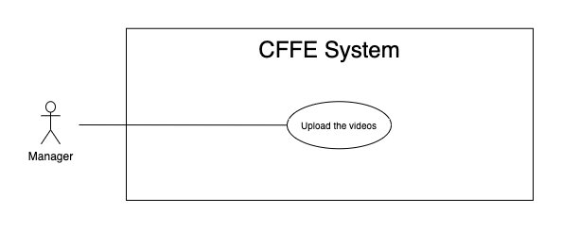

*Figure 21 - <Use Case> Upload the videos*

|  |  |  |  |
| --- | --- | --- | --- |
| ID and Name: | **UC-24 Upload the videos** | | |
| Created By: | HuuDN | Date Created: | 10/05/2021 |
| Primary Actor: | Manager | Secondary Actors: | N/A |
| Description: | This feature allows Manager to upload the videos. | | |
| Trigger: | Manager sends a request to upload the videos. | | |
| Preconditions: | PRE-01. User has logged in the system as manager role.  PRE-02. Manager is on "Video" page. | | |
| Post-conditions: | POST-01:   * Success: CFFE system shows success message and closes "Upload" popup. * Fail: CFFE system shows error message. | | |
| Normal Flow: | **24.0 Upload the videos**   1. Manager clicks on "Upload video" button on the search bar. 2. CFFE systems displays the upload popup that includes:    * "Upload video area": upload area    * "OK": button    * "Cancel": button 3. Manager clicks or drags the videos into upload area. 4. Manager clicks on "OK" button. (Alternative 24.0, 24.1) 5. CFFE system validates the videos. (Exception 24.0.E1, 24.0.E2, 24.0.E3) 6. CFFE system uploads the videos and returns the success message (MSG-010). | | |
| Alternative Flows: | **24.0 Manager cancels the updating process.**   1. Manager clicks on "Cancel" button. 2. CFFE system closes this popup and terminates this use case.   **24.1 Manager clicks outside of popup.**   1. Manager clicks outside of popup. 2. CFFE system closes this popup and terminates this use case. | | |
| Exceptions: | **24.0.E1 Manager does not select the required video.**   1. CFFE system returns to Manager to select the video again (MSG-119). 2. If Manager inputs the required fields again, CFFE system returns to step 3 of the normal flow. 3. Else if Manager cancels the uploading process, then CFFE system terminates this use case.   **24.0.E2 Manager selects the videos that do not valid.**   1. CFFE system shows error message (MSG-118, MSG-119, MSG-122, MSG-123) and terminates this use case.   **24.0.E3 CFFE system cannot upload the videos.**   1. CFFE system shows error message (MSG-114) and terminates this use case. | | |
| Priority: | High | | |
| Frequency of Use: | Often | | |
| Business Rules: | BR-019, BR-020 | | |
| Other Information: | In case of internet connection failure, Manager cannot finish this use case properly. | | |
| Assumptions: | N/A | | |

*Table 20 - <Use Case> Upload the videos*

#### 2.2.4 <Admin> Overview Use Case

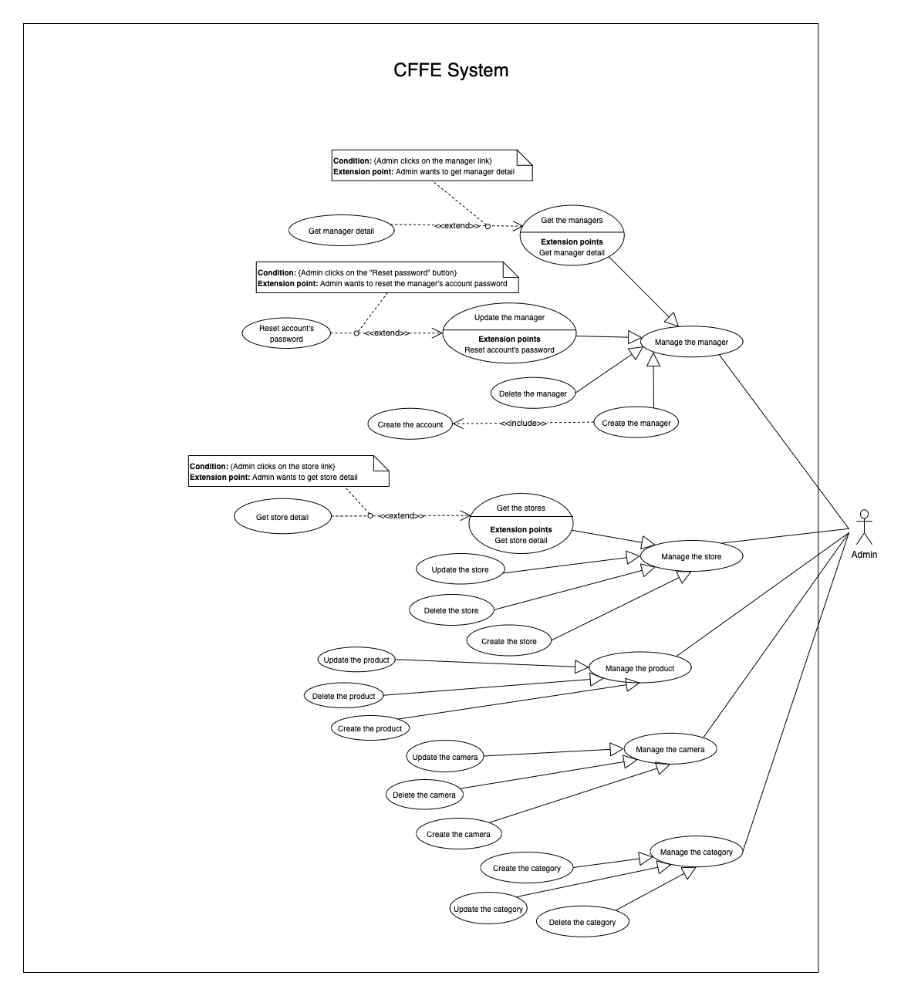*Figure 36 - <Use Case> Get the cameras*

##### 2.2.4.1 <Admin> Get the stores

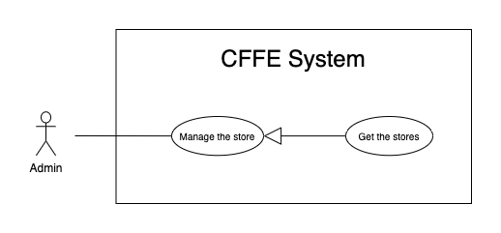

*Figure 37 - <Use Case> Get the stores*

|  |  |  |  |
| --- | --- | --- | --- |
| ID and Name: | **UC-25 Get the stores** | | |
| Created By: | LuanNM | Date Created: | 08/05/2021 |
| Primary Actor: | Admin | Secondary Actors: | N/A |
| Description: | This feature allows admin to get the stores. | | |
| Trigger: | Admin sends a request to get the stores. | | |
| Pre-conditions: | PRE-01. User has logged into the system as admin role. | | |
| Post-conditions: | POST-01. CFFE system returns the list of stores. | | |
| Normal Flow: | **25.0 Get the stores**   1. Admin clicks on "Store" button on the navigation bar. 2. CFFE system requires the store information from Admin:  * “Store name”: input text * “City”: select box * “Status”: select box  1. Admin inputs/selects the fields. 2. CFFE system returns the list of stores based on below conditions and display them (Exception 25.0.E1). | | |
| Alternative Flows: | N/A | | |
| Exceptions: | **25.0.E1 The list of stores has no data.**   1. CFFE system returns the message (MSG-009). | | |
| Priority: | High | | |
| Frequency of Use: | Usually | | |
| Business Rules: | BR-059, BR-064, BR-065 | | |
| Other Information: | In case of internet connection failure, Admin cannot finish this use case properly. | | |
| Assumptions: | N/A | | |

*Table 35 - <Use Case> Get the stores*

##### 2.2.4.2 <Admin> Get store detail

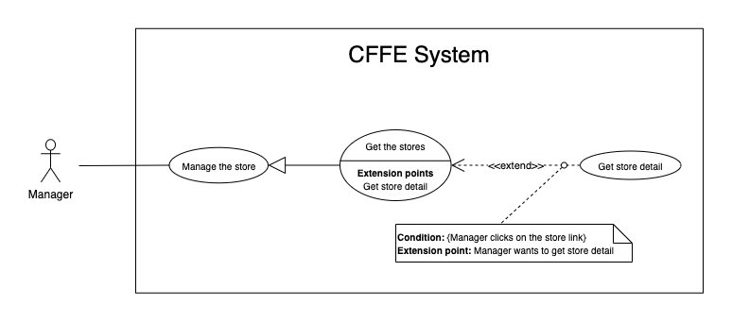

*Figure 38 - <Use Case> Get store detail*

|  |  |  |  |
| --- | --- | --- | --- |
| ID and Name: | **UC-26 Get store detail** | | |
| Created By: | LuanNM | Date Created: | 10/05/2021 |
| Primary Actor: | Admin | Secondary Actors: | N/A |
| Description: | This feature allows the admin to getstoredetail. | | |
| Trigger: | Admin sends a request to get store detail. | | |
| Preconditions: | PRE-01. User has logged in the system as admin role.  PRE-02. There is at least one store link. | | |
| Post-conditions: | POST-01:   * Success: CFFE system returns store detail successfully and redirects to "Store Detail" page. * Fail: CFFE system shows error message. | | |
| Normal Flow: | **26.0 Get store detail**   1. Admin clicks on the store link. 2. CFFE system validates the store exists (Exception 26.0.E1) 3. CFFE system returns the stores information and redirects to store detail page. | | |
| Alternative Flows: | N/A | | |
| Exceptions: | **26.0.E1 The stores does not exist.**  1. CFFE system returns the message (MSG-035) and terminates this use case. | | |
| Priority: | High | | |
| Frequency of Use: | Usually | | |
| Business Rules: | BR-059, BR-066 | | |
| Other Information: | In case of internet connection failure, Admin cannot finish this use case properly. | | |
| Assumptions: | N/A | | |

*Table 36 - <Use Case> Get camera detail*

##### 2.2.4.3 <Admin> Update the store

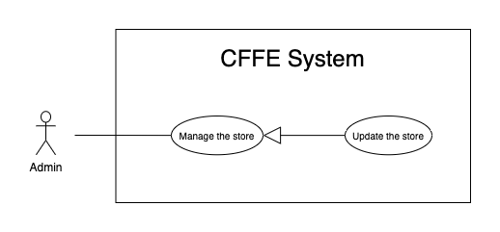

*Figure 39 - <Use Case> Update the store*

|  |  |  |  |
| --- | --- | --- | --- |
| ID and Name: | **UC-27 Update the store** | | |
| Created By: | LuanNM | Date Created: | 18/06/2021 |
| Primary Actor: | Admin | Secondary Actors: | N/A |
| Description: | This feature allows Admin to update store in CFFE system. | | |
| Trigger: | Admin sends a request to update the store. | | |
| Preconditions: | PRE-01. User has logged in the system as admin role.  PRE-02. Admin is on “Store detail” page. | | |
| Post-conditions: | POST-01:   * Success: CFFE system shows success message and reloads "Store Detail" page. * Fail: CFFE system shows error message. | | |
| Normal Flow: | **27.0 Update the store information** (Alternative 27.0, 27.1, 27.2, 27.3)   1. Admin clicks on "Edit Information" button. 2. CFFE system requires store information that includes:  * “Store Name”: input text * “Address”: input text * “City”: select box * “District”: select box * “Update”: button * “Cancel”: button  1. Admin inputs/selects the required fields. 2. Admin clicks on “Update” button. (Alternative 27.4) 3. CFFE system validates the fields (Exception 27.0.E1, 27.0.E2) 4. CFFE system updates store information and returns the success message (MSG-013). | | |
| Alternative Flows: | **27.0 Adding the manager to managing this store**   1. Admin clicks on "Add manager" button. 2. CFFE system shows popup that includes:    * "Manager": list box    * "OK": button    * "Cancel": button 3. Admin clicks on a manager box. 4. Admin clicks on "OK" button. (Alternative 27.4, 27.5) 5. CFFE system validates the chosen manager and store. (Exception 27.0.E3, 27.0.E4) 6. CFFE system adds the manager to the store and returns the success message. (MSG-013)   **27.1 Removing the manager from this store**   1. Admin clicks on "Remove manager" button. 2. CFFE system shows confirm popup with message "Do you want to remove this manager from this store?" and two buttons for Admin selecting:    * "OK" button    * "Cancel" button 3. Admin clicks on "OK" button. (Alternative 27.4, 27.5) 4. CFFE system validates the manager and store. (Exception 27.0.E5, 27.0.E6, 27.0.E7) 5. CFFE system remove the manager from the store and returns the success message (MSG-013).   **27.2 Updating store's image.**   1. Admin clicks on "Update image" button. 2. CFFE system shows updating image popup for Admin selecting:    * "Image": label    * "Choose": button    * "OK": button    * "Cancel": button 3. Admin clicks on "Choose" button. 4. Admin selects an image. 5. Admin clicks on "OK" button. (Alternative 27.4, 27.5) 6. CFFE system validates the image. (Exception 27.0.E9, 27.0.E10, 27.0.E11) 7. CFFE system updates the store's image and returns the success message (MSG-013).   **27.3 Reactivate the inactive store.**   1. Admin focus on "Inactive" button then clicks on "Pending" button. 2. CFFE system shows confirm popup with message "Do you want to active this store?" and two buttons for Admin selecting:    * "OK" button    * "Cancel" button 3. Admin clicks on "OK" button. (Alternative 27.4, 27.5) 4. CFFE system validates the store. (Exception 27.0.E5) 5. CFFE system updates the store's status and returns the success message (MSG-013).   **27.4 Admin cancels the updating process.**   1. Admin clicks on "Cancel" button. 2. CFFE system closes this popup and terminates this use case.   **27.5 Admin clicks outside of popup.**   1. Admin clicks outside of popup. 2. CFFE system closes this popup and terminates this use case. | | |
| Exceptions: | **27.0.E1 Admin does not input/select the required fields**   1. CFFE system returns to Admin to input/select the required fields again (MSG-106, MSG-036, MSG-038, MSG-039). 2. If Admin inputs/selects the required fields again, CFFE system returns to step 3 of the normal flow. 3. Else if Admin cancels the updating process, then CFFE system terminates this use case.   **27.0.E2 Admin inputs/selects the fields that are not valid**   1. CFFE system returns to Admin to input/select the fields again (MSG-129, MSG-037). 2. If Admin inputs/selects the fields again, CFFE system returns to step 3 of the normal flow. 3. Else if Admin cancels the updating process, then CFFE system terminates this use case.   **27.0.E3 Store does not exist or has not pending status.**   1. CFFE system returns error message (MSG-075) and terminates this use case.   **27.0.E4 Manager does not exist or has not pending status.**   1. CFFE system returns error message (MSG-074) and terminates this use case.   **27.0.E5 Store does not exist.**   1. CFFE system returns error message (MSG-035) and terminates this use case.   **27.0.E6 Manager does not exist.**   1. CFFE system returns error message (MSG-041) and terminates this use case.   **27.0.E7 Manager is not managing this store**   1. CFFE system returns error message (MSG-077) and terminates this use case.   **27.0.E8 Manager is not managing this store**   1. CFFE system returns error message (MSG-077) and terminates this use case.   **27.0.E9 Admin does not select the image**   1. CFFE system returns to Admin to select the image again (MSG-112). 2. If Admin selects the image again, CFFE system returns to step 3 of the alternative flow 27.2. 3. Else if Admin cancels the updating process, then CFFE system terminates this use case.   **27.0.E10 Image is not jpg/jpeg/png format.**   1. CFFE system returns to Admin to select the image again (MSG-113). 2. If Admin selects the image again, CFFE system returns to step 3 of the alternative flow 27.2. 3. Else if Admin cancels the updating process, then CFFE system terminates this use case.   **27.0.E11 CFFE system cannot upload the image.**   1. CFFE system shows error message (MSG-114) and terminates this use case. | | |
| Priority: | Medium | | |
| Frequency of Use: | Often | | |
| Business Rules: | BR-032, BR-040, BR-059, BR-067, BR-68 | | |
| Other Information: | In case of internet connection failure, Admin cannot finish this use case properly. | | |
| Assumptions: | N/A | | |

*Table 37 - <Use Case> Update the store*

##### 2.2.4.4 <Admin> Delete the store

*Figure 40 - <Use Case> Delete the store*

|  |  |  |  |
| --- | --- | --- | --- |
| ID and Name: | **UC-28 Delete the store** | | |
| Created By: | LuanNM | Date Created: | 10/05/2021 |
| Primary Actor: | Admin | Secondary Actors: | N/A |
| Description: | This feature allows Admin to delete the store. | | |
| Trigger: | Admin sends a request to delete the store. | | |
| Preconditions: | PRE-01. User has logged in the system as admin role.  PRE-02. Admin is on “Store detail” page. | | |
| Post-conditions: | POST-01:   * Success: CFFE system shows success message and reloads "Store Detail" page. * Fail: CFFE system shows error message. | | |
| Normal Flow: | **28.0 Delete the store**   1. Admin focus on "Pending" button then clicks on "Inactive" button. 2. CFFE system shows delete popup with message: "Do you want to inactive this store?" and required form:  * "Inactive reason": text area * "OK": button * "Cancel" button  1. Admin inputs the field. 2. Admin clicks on "OK" button. (Alternative 28.0, 28.1) 3. CFFE system validates the required field and the store. (Exception 28.0.E1, 28.0.E2, 28.0.E3) 4. CFFE system updates the store's status and returns the success message (MSG-040). | | |
| Alternative Flows: | **28.0 Admin cancels the deleting process.**   1. Admin clicks on "Cancel" button. 2. CFFE system closes this popup and terminates this use case.   **28.1 Admin clicks outside of popup.**   1. Admin clicks outside of popup. 2. CFFE system closes this popup and terminates this use case. | | |
| Exceptions: | **28.0.E1 The store does not exist**   1. CFFE system returns error message (MSG-012) and terminates this use case.   **28.0.E2 The store has an manager that is managing and has active or pending shelves.**   1. CFFE system returns error message (MSG-066, MSG-081) and terminates this use case.   **28.0.E3 Admin inputs the inactive reason fields that are not valid**   1. CFFE system returns error message (MSG-067) and terminates this use case. | | |
| Priority: | Medium | | |
| Frequency of Use: | Often | | |
| Business Rules: | BR-032, BR-033, BR-059, BR-069 | | |
| Other Information: | In case of internet connection failure, Admin cannot finish this use case properly. | | |
| Assumptions: | N/A | | |

*Table 38 - <Use Case> Delete the store*

##### 2.2.4.5 <Admin> Create the store

*Figure 41 - <Use Case> Create the store*

|  |  |  |  |
| --- | --- | --- | --- |
| ID and Name: | **UC-29 Create the store** | | |
| Created By: | LuanNM | Date Created: | 10/05/2021 |
| Primary Actor: | Admin | Secondary Actors: | N/A |
| Description: | This feature allows Admin to create the store. | | |
| Trigger: | Admin sends a request to create the store. | | |
| Preconditions: | PRE-01. User has logged in the system as admin role.  PRE-02. Admin is on “Store” page. | | |
| Post-conditions: | POST-01:   * Success: CFFE system shows success message and reloads "Store" page. * Fail: CFFE system shows error message. | | |
| Normal Flow: | **29.0 Create the store**   1. Admin clicks on "New" button. 2. CFFE system shows creating store popup that includes:    * "Store name": input text    * "Image": button    * "Address": input text    * "City": select box    * "District": select box    * "Create": button    * "Cancel": button 3. Admin inputs/selects the required fields. 4. Admin clicks on the "Create" button to create new store. (Alternative 29.0, 29.1) 5. CFFE system validates the required fields (Exception 29.0.E1, 29.0.E2). 6. CFFE system stores newly created store and returns the success message (MSG-011). | | |
| Alternative Flows: | **29.0 Admin cancels the creating process.**   1. Admin clicks on "Cancel" button. 2. CFFE system closes this popup and terminates this use case.   **29.1 Admin clicks outside of popup.**   1. Admin clicks outside of popup. 2. CFFE system closes this popup and terminates this use case. | | |
| Exceptions: | **29.0.E1 Admin does not input/select the required fields**   1. CFFE system returns to Admin to input/select the required fields again (MSG-106, MSG-036, MSG-038, MSG-039). 2. If Admin inputs/selects the required fields again, CFFE system returns to step 3 of the normal flow. 3. Else if Admin cancels the creating process, then CFFE system terminates this use case.   **29.0.E2 Admin** **inputs/selects the fields that are not valid**   1. CFFE system returns to Admin to input/select the fields again (MSG-109, MSG-037, MSG-062). 2. If Admin inputs/selects the fields again, CFFE system returns to step 3 of the normal flow. 3. Else if Admin cancels the creating process, then CFFE system terminates this use case. | | |
| Priority: | Medium | | |
| Frequency of Use: | Often | | |
| Business Rules: | BR-035, BR-059, BR-067, BR-070 | | |
| Other Information: | In case of internet connection failure, Admin cannot finish this use case properly. | | |
| Assumptions: | N/A | | |

*Table 39 - <Use Case> Create the store*

##### 2.2.4.6 <Admin> Get the managers

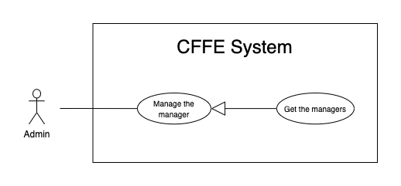

*Figure 37 - <Use Case> Get the manager*

|  |  |  |  |
| --- | --- | --- | --- |
| ID and Name: | **UC-30 Get the managers** | | |
| Created By: | HieuNT | Date Created: | 08/05/2021 |
| Primary Actor: | Admin | Secondary Actors: | N/A |
| Description: | This feature allows admin to get the managers. | | |
| Trigger: | Admin sends a request to get the managers. | | |
| Pre-conditions: | PRE-01. User has logged into the system as admin role. | | |
| Post-conditions: | POST-01. CFFE system returns the list of stores. | | |
| Normal Flow: | **30.0 Get the managers**   1. Admin clicks on "Manager" button on the navigation bar. 2. CFFE system requires the manager information from Admin:  * “Name”: input text, blank * “Options”: input text, blank * “Status”: combobox  1. Admin inputs/selects the fields. 2. CFFE system returns the list of stores based on below conditions and display them (Exception 30.0.E1). | | |
| Alternative Flows: | N/A | | |
| Exceptions: | **30.0.E1 The list of managers has no data.**   1. CFFE system returns the message (MSG-009). | | |
| Priority: | High | | |
| Frequency of Use: | Usually | | |
| Business Rules: | BR-015, BR-017, BR-034 | | |
| Other Information: | In case of internet connection failure, Admin cannot finish this use case properly. | | |
| Assumptions: | N/A | | |

*Table 40 - <Use Case> Get the managers*

##### 2.2.4.7 <Admin> Get manager detail

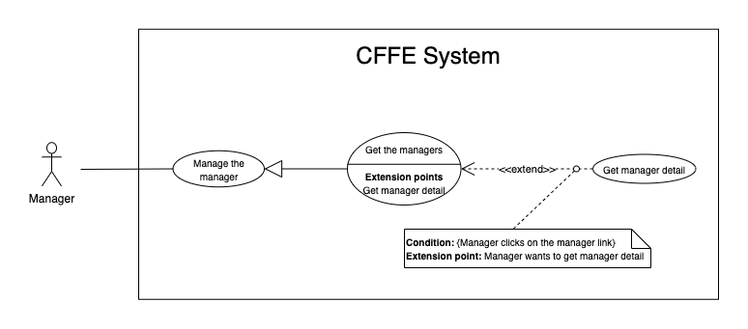

*Figure 43 - <Use Case> Get store detail*

|  |  |  |  |
| --- | --- | --- | --- |
| ID and Name: | **UC-31 Get manager detail** | | |
| Created By: | HieuNT | Date Created: | 10/05/2021 |
| Primary Actor: | Admin | Secondary Actors: | N/A |
| Description: | This feature allows the admin to getmanagerdetail. | | |
| Trigger: | Admin sends a request to get manager detail. | | |
| Preconditions: | PRE-01. User has logged in the system as admin role.  PRE-02. There is at least one manager link. | | |
| Post-conditions: | POST-01:   * Success: CFFE system returns manager detail successfully and redirects to "Manager Detail" page. * Fail: CFFE system shows error message. | | |
| Normal Flow: | **31.0 Get manager detail**   1. Admin clicks on the manager link. 2. CFFE system validates the manager exists (Exception 31.0.E1) 3. CFFE system returns the manager information and redirects to manager detail page. | | |
| Alternative Flows: | N/A | | |
| Exceptions: | **31.0.E1 The manager does not exist.**  1. CFFE system returns the message (MSG-041) and terminates this use case. | | |
| Priority: | High | | |
| Frequency of Use: | Usually | | |
| Business Rules: | BR-034, BR-061 | | |
| Other Information: | In case of internet connection failure, Admin cannot finish this use case properly. | | |
| Assumptions: | N/A | | |

*Table 42 - <Use Case> Get manager detail*

##### 2.2.4.8 <Admin> Update the manager

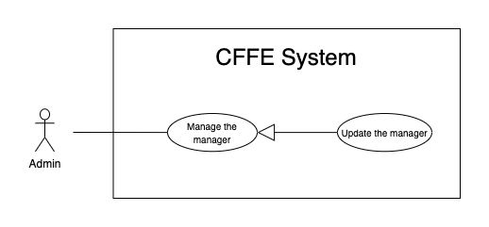

*Figure 44 - <Use Case> Update the manager*

|  |  |  |  |
| --- | --- | --- | --- |
| ID and Name: | **UC-32 Update the manager** | | |
| Created By: | HieuNT | Date Created: | 18/06/2021 |
| Primary Actor: | Admin | Secondary Actors: | N/A |
| Description: | This feature allows Admin to update manager in CFFE system. | | |
| Trigger: | Admin sends a request to update the manager. | | |
| Preconditions: | PRE-01. User has logged in the system as admin role.  PRE-02. Admin is on “Manager detail” page. | | |
| Post-conditions: | POST-01:   * Success: CFFE system shows success message and reloads "Manager Detail" page. * Fail: CFFE system shows error message. | | |
| Normal Flow: | **32.0 Update the manager information** (Alternative 32.0, 32.1, 32.2, 32.3, 32.4)   1. Admin clicks on "Edit information" button. 2. CFFE system requires store information that includes:  * “Full name”: input text * “Gender”: checkbox * “Birthday”: date picker * “Identify card”: input text * “Phone number”: input text * “Email”: input text * “Address”: input text * “City”: select box * “District”: select box * “Update”: button * “Cancel”: button  1. Admin inputs/selects the required fields. 2. Admin clicks on “Update” button. (Alternative 32.4) 3. CFFE system validates the fields (Exception 32.0.E1, 32.0.E2) 4. CFFE system updates manager information and returns the success message (MSG-013). | | |
| Alternative Flows: | **32.0 Adding the store to manage**   1. Admin clicks on "Add store" button. 2. CFFE system shows popup that includes:    * "Store": list box    * "OK": button    * "Cancel": button 3. Admin clicks on a store box. 4. Admin clicks on "OK" button. (Alternative 32.4, 32.5) 5. CFFE system validates the chosen manager and store. (Exception 32.0.E3, 32.0.E4) 6. CFFE system adds the store to the manager and returns the success message. (MSG-013)   **32.1 Removing the store that is managing**   1. Admin clicks on "Remove store" button. 2. CFFE system shows confirm popup with message "Do you want to remove this store from this manager?" and two buttons for Admin selecting:    * "OK" button    * "Cancel" button 3. Admin clicks on "OK" button. (Alternative 32.4, 32.5) 4. CFFE system validates the manager and store. (Exception 32.0.E5, 32.0.E6, 32.0.E7) 5. CFFE system remove the store from the manager and returns the success message (MSG-013).   **32.2 Updating manager avatar.**   1. Admin clicks on "Update avatar" button. 2. CFFE system shows updating image popup for Admin selecting:    * "Avatar": label    * "Choose": button    * "OK": button    * "Cancel": button 3. Admin clicks on "Choose" button. 4. Admin selects an image. 5. Admin clicks on "OK" button. (Alternative 32.4, 32.5) 6. CFFE system validates the image. (Exception 32.0.E9, 32.0.E10, 32.0.E11) 7. CFFE system updates the manager's avatar and returns the success message (MSG-013).   **32.3 Reactivate the inactive manager.**   1. Admin focus on "Inactive" button then clicks on "Pending" button. 2. CFFE system shows confirm popup with message "Do you want to active this manager?" and two buttons for Admin selecting:    * "OK" button    * "Cancel" button 3. Admin clicks on "OK" button. (Alternative 32.4, 32.5) 4. CFFE system validates the manager. (Exception 32.0.E6) 5. CFFE system updates the manager's status and returns the success message (MSG-013).   **32.4 Admin cancels the updating process.**   1. Admin clicks on "Cancel" button. 2. CFFE system closes this popup and terminates this use case.   **32.5 Admin clicks outside of popup.**   1. Admin clicks outside of popup. 2. CFFE system closes this popup and terminates this use case. | | |
| Exceptions: | **32.0.E1 Admin does not input/select the required fields**   1. CFFE system returns to Admin to input/select the required fields again (MSG-014, MSG-036, MSG-038, MSG-039, MSG-049, MSG-044, MSG-047, MSG-051, MSG-054). 2. If Admin inputs/selects the required fields again, CFFE system returns to step 3 of the normal flow. 3. Else if Admin cancels the updating process, then CFFE system terminates this use case.   **32.0.E2 Admin inputs/selects the fields that are not valid**   1. CFFE system returns to Admin to input/select the fields again (MSG-015, MSG-037, MSG-042, MSG-045, MSG-052, MSG-073). 2. If Admin inputs/selects the fields again, CFFE system returns to step 3 of the normal flow. 3. Else if Admin cancels the updating process, then CFFE system terminates this use case.   **32.0.E3 Store does not exist or has not pending status.**   1. CFFE system returns error message (MSG-075) and terminates this use case.   **32.0.E4 Manager does not exist or has not pending status.**   1. CFFE system returns error message (MSG-074) and terminates this use case.   **32.0.E5 Store does not exist.**   1. CFFE system returns error message (MSG-035) and terminates this use case.   **32.0.E6 Manager does not exist.**   1. CFFE system returns error message (MSG-041) and terminates this use case.   **32.0.E7 Manager is not managing this store**   1. CFFE system returns error message (MSG-077) and terminates this use case.   **32.0.E9 Admin does not select the image**   1. CFFE system returns to Admin to select the image again (MSG-112). 2. If Admin selects the image again, CFFE system returns to step 3 of the alternative flow 32.2. 3. Else if Admin cancels the updating process, then CFFE system terminates this use case.   **32.0.E10 Image is not jpg/jpeg/png format.**   1. CFFE system returns to Admin to select the image again (MSG-113). 2. If Admin selects the image again, CFFE system returns to step 3 of the alternative flow 32.2. 3. Else if Admin cancels the updating process, then CFFE system terminates this use case.   **32.0.E11 CFFE system cannot upload the image.**   1. CFFE system shows error message (MSG-114) and terminates this use case. | | |
| Priority: | Medium | | |
| Frequency of Use: | Often | | |
| Business Rules: | BR-032, BR-034, BR-040, BR-060, BR-068 | | |
| Other Information: | In case of internet connection failure, Admin cannot finish this use case properly. | | |
| Assumptions: | N/A | | |

*Table 37 - <Use Case> Update the store*

##### 2.2.4.9 <Admin> Reset account's password

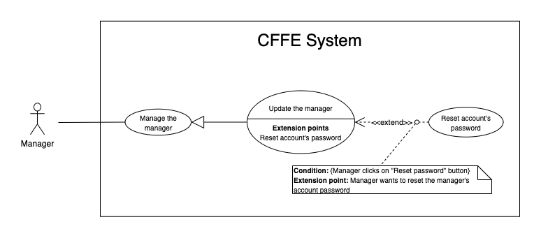

*Figure 44 - <Use Case> Reset account's password*

|  |  |  |  |
| --- | --- | --- | --- |
| ID and Name: | **UC-33 Reset account's password** | | |
| Created By: | HieuNT | Date Created: | 18/06/2021 |
| Primary Actor: | Admin | Secondary Actors: | N/A |
| Description: | This feature allows Admin to reset account's password in CFFE system. | | |
| Trigger: | Admin sends a request to reset account's password. | | |
| Preconditions: | PRE-01. User has logged in the system as admin role.  PRE-02. Admin is on “Manager detail” page. | | |
| Post-conditions: | POST-01:   * Success: CFFE system shows success message and sends account's password to manager's email. * Fail: CFFE system shows error message. | | |
| Normal Flow: | **33.0 Reset account's password**   1. Admin clicks on "Reset password" button. 2. CFFE system shows confirm popup with message "Do you want to reset password?" and two buttons for Admin selecting:    * "OK" button    * "Cancel" button 3. Admin clicks on “OK” button. (Alternative 33.0, 33.1) 4. CFFE system validates the manager and send account's new password to manager's email (Exception 33.0.E1, 33.0.E2) 5. CFFE system updates manager information and returns the success message (MSG-013). | | |
| Alternative Flows: | **33.0 Admin cancels the resetting process.**   1. Admin clicks on "Cancel" button. 2. CFFE system closes this popup and terminates this use case.   **33.1 Admin clicks outside of popup.**   1. Admin clicks outside of popup. 2. CFFE system closes this popup and terminates this use case. | | |
| Exceptions: | **33.0.E1 Manager is not found**   1. CFFE system returns error message (MSG-063) and terminates this use case.   **33.0.E2 Send email failed**   1. CFFE system shows error message (MSG-124) and terminates this use case. | | |
| Priority: | Medium | | |
| Frequency of Use: | Often | | |
| Business Rules: | BR-008, BR-012 | | |
| Other Information: | In case of internet connection failure, Admin cannot finish this use case properly. | | |
| Assumptions: | N/A | | |

*Table 37 - <Use Case> Reset account's password*

##### 2.2.4.10 <Admin> Delete the manager

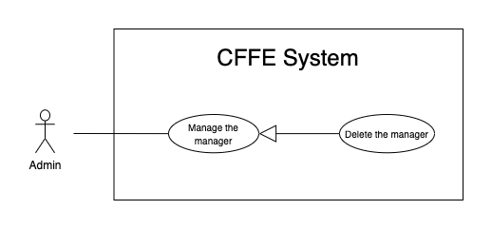

*Figure 45 - <Use Case> Delete the manager*

|  |  |  |  |
| --- | --- | --- | --- |
| ID and Name: | **UC-34 Delete the manager** | | |
| Created By: | LuanNM | Date Created: | 10/05/2021 |
| Primary Actor: | Admin | Secondary Actors: | N/A |
| Description: | This feature allows Admin to delete the manager. | | |
| Trigger: | Admin sends a request to delete the manager. | | |
| Preconditions: | PRE-01. User has logged in the system as admin role.  PRE-02. Admin is on “Manager detail” page. | | |
| Post-conditions: | POST-01:   * Success: CFFE system shows success message and reloads "Manager Detail" page. * Fail: CFFE system shows error message. | | |
| Normal Flow: | **34.0 Delete the manager**   1. Admin focus on "Pending" button then clicks on "Inactive" button. 2. CFFE system shows delete popup with message: "Do you want to inactive this manager?" and required form:  * "Inactive reason": text area * "OK": button * "Cancel" button  1. Admin inputs the field. 2. Admin clicks on "OK" button. (Alternative 34.0, 34.1) 3. CFFE system validates the required field and the manager. (Exception 34.0.E1, 34.0.E2, 34.0.E3) 4. CFFE system updates the manager's status and returns the success message (MSG-040). | | |
| Alternative Flows: | **34.0 Admin cancels the deleting process.**   1. Admin clicks on "Cancel" button. 2. CFFE system closes this popup and terminates this use case.   **34.1 Admin clicks outside of popup.**   1. Admin clicks outside of popup. 2. CFFE system closes this popup and terminates this use case. | | |
| Exceptions: | **34.0.E1 Manager is not found**   1. CFFE system returns error message (MSG-063) and terminates this use case.   **34.0.E2 Manager is managing a store**   1. CFFE system shows error message (MSG-066) and terminates this use case.   **34.0.E3 Admin inputs the inactive reason fields that are not valid**   1. CFFE system returns error message (MSG-067) and terminates this use case. | | |
| Priority: | Medium | | |
| Frequency of Use: | Often | | |
| Business Rules: | BR-003, BR-032, BR-033, BR-034 | | |
| Other Information: | In case of internet connection failure, Admin cannot finish this use case properly. | | |
| Assumptions: | N/A | | |

*Table 38 - <Use Case> Delete the manager*

##### 2.2.4.11 <Admin> Create the manager

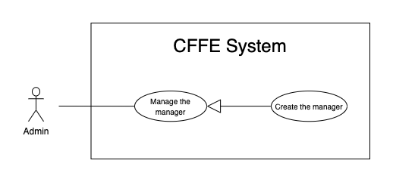

*Figure 46 - <Use Case> Create the manager*

|  |  |  |  |
| --- | --- | --- | --- |
| ID and Name: | **UC-35 Create the manager** | | |
| Created By: | LuanNM | Date Created: | 10/05/2021 |
| Primary Actor: | Admin | Secondary Actors: | N/A |
| Description: | This feature allows Admin to create the manager. | | |
| Trigger: | Admin sends a request to create the manager. | | |
| Preconditions: | PRE-01. User has logged in the system as admin role.  PRE-02. Admin is on “Manager” page. | | |
| Post-conditions: | POST-01:   * Success: CFFE system shows success message and reloads "Manager" page. * Fail: CFFE system shows error message. | | |
| Normal Flow: | **35.0 Create the manager**   1. Admin clicks on "New" button. 2. CFFE system shows creating popup that includes:    * "Avatar": button    * "Full name": input text    * "Email": input text    * "Identity card": input text    * "Phone number": input text    * "Gender": checkbox    * "Birthday": date picker    * "Address": input text    * "City": select box    * "District": select box    * "Create": button    * "Cancel": button 3. Admin inputs/selects the required fields. 4. Admin clicks on the "Create" button to create the manager. (Alternative 35.0, 35.1) 5. CFFE system validates the required fields. (Exception 35.0.E1, 35.0.E2) 6. CFFE system stores newly created manager, returns the success message (MSG-011). | | |
| Alternative Flows: | **35.0 Admin cancels the creating process.**   1. Admin clicks on "Cancel" button. 2. CFFE system closes this popup and terminates this use case.   **35.1 Admin clicks outside of popup.**   1. Admin clicks outside of popup. 2. CFFE system closes this popup and terminates this use case. | | |
| Exceptions: | **35.0.E1 Admin does not input/select the required fields**   1. CFFE system returns to Admin to input/select the required fields again (MSG-014, MSG-036, MSG-038, MSG-039, MSG-044, MSG-047, MSG-049, MSG-051, MSG-054). 2. If Admin inputs/selects the required fields again, CFFE system returns to step 3 of the normal flow. 3. Else if Admin cancels the creating process, then CFFE system terminates this use case.   **35.0.E2 Admin inputs/selects the fields that are not valid**   1. CFFE system returns to Admin to input/select the fields again (MSG-015, MSG-037, MSG-042, MSG-045, MSG-048, MSG-052, MSG-055, MSG-056, MSG-073). 2. If Admin inputs/selects the fields again, CFFE system returns to step 3 of the normal flow. 3. Else if Admin cancels the creating process, then CFFE system terminates this use case. | | |
| Priority: | Medium | | |
| Frequency of Use: | Often | | |
| Business Rules: | BR-034, BR-035, BR-060, BR-070 | | |
| Other Information: | In case of internet connection failure, Admin cannot finish this use case properly. | | |
| Assumptions: | N/A | | |

*Table 47 - <Use Case> Create the manager*

##### 2.2.4.12 <Admin> Create the account

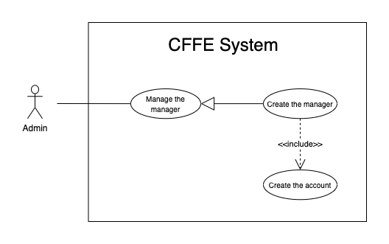

*Figure 46 - <Use Case> Create the account*

|  |  |  |  |
| --- | --- | --- | --- |
| ID and Name: | **UC-36 Create the account** | | |
| Created By: | LuanNM | Date Created: | 10/05/2021 |
| Primary Actor: | Admin | Secondary Actors: | N/A |
| Description: | This feature allows Admin to create the manager. | | |
| Trigger: | Admin sends a request to create the account. | | |
| Preconditions: | PRE-01. User has logged in the system as admin role.  PRE-02. Admin creates a manager successfully. | | |
| Post-conditions: | POST-01. CFFE system stores newly accounts and sends manager's account to manager's email. | | |
| Normal Flow: | **36.0 Create the account**   1. CFFE system creates the account for newly manager and sends account to manager's email. | | |
| Alternative Flows: | N/A | | |
| Exceptions: | **36.0.E1 Send email failed**   1. CFFE system shows error message (MSG-124) and terminates this use case. | | |
| Priority: | Medium | | |
| Frequency of Use: | Often | | |
| Business Rules: | BR-008, BR-012, BR-043 | | |
| Other Information: | In case of internet connection failure, Admin cannot finish this use case properly. | | |
| Assumptions: | N/A | | |

*Table 47 - <Use Case> Create new account*

##### 2.2.3.13 <Admin> Update the product

*Figure 24 - <Use Case> Update the product*

|  |  |  |  |
| --- | --- | --- | --- |
| ID and Name: | **UC-37 Update the product** | | |
| Created By: | HieuNT | Date Created: | 18/06/2021 |
| Primary Actor: | Admin | Secondary Actors: | N/A |
| Description: | This feature allows admin to update product in CFFE system. | | |
| Trigger: | Admin sends a request to update the product. | | |
| Preconditions: | PRE-01. User has logged in the system as admin role.  PRE-02. Admin is on “Product detail” page. | | |
| Post-conditions: | POST-01:   * Success: CFFE system shows success message and reloads "Product Detail" page. * Fail: CFFE system shows error message. | | |
| Normal Flow: | **37.0 Update the product information** (Alternative 37.0, 37.1)   1. Admin clicks on "Edit information" button on the About box. 2. CFFE system requires product popup that includes:  * “Product name”: input text * “Description”: input text * “Category”: dropdown list * "Update": button * "Cancel": button  1. Admin inputs/selects the required fields. 2. Admin clicks on “Update” button. (Alternative 37.2) 3. CFFE system validates the fields. (Exception 37.0.E1, 37.0.E2, 37.0.E6) 4. CFFE system updates product information and returns the success message (MSG-013). | | |
| Alternative Flows: | **37.0 Updating product image.**   1. Admin clicks on "Update avatar" button. 2. CFFE system shows updating image popup for Admin selecting:    * "Avatar": label    * "Choose": button    * "OK": button    * "Cancel": button 3. Admin clicks on "Choose" button. 4. Admin selects an image. 5. Admin clicks on "OK" button. (Alternative 37.2, 37.3) 6. CFFE system validates the image. (Exception 37.0.E3, 37.0.E4, 37.0.E5, 37.0.E6) 7. CFFE system updates the product's image and returns the success message (MSG-013).   **37.1 Reactivate the inactive product.**   1. Admin focus on "Inactive" button then clicks on "Active" button. 2. CFFE system shows confirm popup with message "Do you want to active this product?" and two buttons for Admin selecting:    * "OK" button    * "Cancel" button 3. Admin clicks on "OK" button. (Alternative 37.2, 37.3) 4. CFFE system validates the product. (Exception 37.0.E6) 5. CFFE system updates the product's status and returns the success message (MSG-013).   **37.2 Admin cancels the updating process.**   1. Admin clicks on "Cancel" button. 2. CFFE system closes this popup and terminates this use case.   **37.3 Admin clicks outside of popup.**   1. Admin clicks outside of popup. 2. CFFE system closes this popup and terminates this use case. | | |
| Exceptions: | **37.0.E1 Admin does not input/select the required fields**   1. CFFE system returns to Admin to input/select the required fields again (MSG-016, MSG-099, MSG-102). 2. If Admin inputs/selects the required fields again, CFFE system returns to step 3 of the normal flow. 3. Else if Admin cancels the updating process, then CFFE system terminates this use case.   **37.0.E2 Admin inputs/selects the fields that are not valid**   1. CFFE system returns to Admin to input/select the fields again (MSG-017, MSG-060, MSG-103, MSG-104, MSG-130). 2. If Admin inputs/selects the fields again, CFFE system returns to step 3 of the normal flow. 3. Else if Admin cancels the updating process, then CFFE system terminates this use case.   **37.0.E3 Admin does not select the image**   1. CFFE system returns to Admin to select the image again (MSG-112). 2. If Admin selects the image again, CFFE system returns to step 3 of the alternative flow 37.0. 3. Else if Admin cancels the updating process, then CFFE system terminates this use case.   **37.0.E4 Image is not jpg/jpeg/png format.**   1. CFFE system returns to Admin to select the image again (MSG-113). 2. If Admin selects the image again, CFFE system returns to step 3 of the alternative flow 37.0. 3. Else if Admin cancels the updating process, then CFFE system terminates this use case.   **37.0.E5 CFFE system cannot upload the image.**   1. CFFE system shows error message (MSG-114) and terminates this use case.   **37.0.E6 Product does not exist.**   1. CFFE system returns error message (MSG-023) and terminates this use case. | | |
| Priority: | Medium | | |
| Frequency of Use: | Often | | |
| Business Rules: | BR-032, BR-047 | | |
| Other Information: | In case of internet connection failure, Admin cannot finish this use case properly. | | |
| Assumptions: | N/A | | |

*Table 13 - <Use Case> Update the product*

##### 2.2.3.15 <Admin> Delete the product

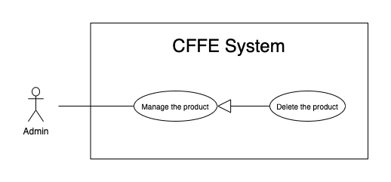

*Figure 24 - <Use Case> Delete the product*

|  |  |  |  |
| --- | --- | --- | --- |
| ID and Name: | **UC-38 Delete the product** | | |
| Created By: | HieuNT | Date Created: | 10/05/2021 |
| Primary Actor: | Admin | Secondary Actors: | N/A |
| Description: | This feature allows Admin to delete the product. | | |
| Trigger: | Admin sends a request to delete the product. | | |
| Preconditions: | PRE-01. User has logged in the system as Admin role.  PRE-02. Admin is on “Product detail” page. | | |
| Post-conditions: | POST-01:   * Success: CFFE system shows success message and reloads "Product Detail" page. * Fail: CFFE system shows error message. | | |
| Normal Flow: | **38.0 Delete the product**   1. Admin focus on "Active" button then clicks on "Inactive" button. 2. CFFE system shows delete popup with message: "Do you want to inactive this product?" and required form:  * "Inactive reason": text area * "OK": button * "Cancel" button  1. Admin inputs the field. 2. Admin clicks on "OK" button. (Alternative 38.0, 38.1) 3. CFFE system validates the product. (Exception 38.0.E1, 38.0.E2, 38.E3) 4. CFFE system updates the product's status and returns the success message (MSG-040). | | |
| Alternative Flows: | **38.0 Admin cancels the deleting process.**   1. Admin clicks on "Cancel" button. 2. CFFE system closes this popup and terminates this use case.   **38.1 Admin clicks outside of popup.**   1. Admin clicks outside of popup. 2. CFFE system closes this popup and terminates this use case. | | |
| Exceptions: | **38.0.E1 Product does not exist**   1. CFFE system returns error message (MSG-023) and terminates this use case.   **38.0.E2 The product is still on the stack.**   1. CFFE system shows error message (MSG-097) and terminates this use case.   **38.0.E3 Admin inputs the inactive reason fields that are not valid**   1. CFFE system returns error message (MSG-067) and terminates this use case. | | |
| Priority: | Medium | | |
| Frequency of Use: | Often | | |
| Business Rules: | BR-032, BR-033, BR-049 | | |
| Other Information: | In case of internet connection failure, Admin cannot finish this use case properly. | | |
| Assumptions: | N/A | | |

*Table 24 - <Use Case> Delete the product*

##### 2.2.3.15 <Admin> Create the product

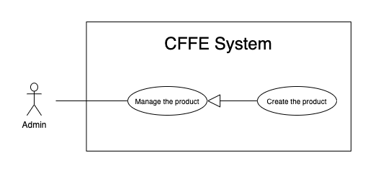

*Figure 26 - <Use Case> Create new product*

|  |  |  |  |
| --- | --- | --- | --- |
| ID and Name: | **UC-39 Create the product** | | |
| Created By: | HieuNT | Date Created: | 10/05/2021 |
| Primary Actor: | Admin | Secondary Actors: | N/A |
| Description: | This feature allows Admin to create the product. | | |
| Trigger: | Admin sends a request to create the product. | | |
| Preconditions: | PRE-01. User has logged in the system as Admin role.  PRE-02. Admin is on “Product” page. | | |
| Post-conditions: | POST-01:   * Success: CFFE system shows success message and reloads "Product" page. * Fail: CFFE system shows error message. | | |
| Normal Flow: | **39.0 Create the product**   1. Admin clicks on "New" button to create new product. 2. CFFE system requires the product information:    * "Image": button    * "Product name": input text    * "Description": input text    * "Category": dropdown list    * "Create": button    * "Cancel": button 3. Admin inputs/selects the required fields. 4. Admin clicks on the "Create" button to create new product. (Alternative 39.0, 39.1) 5. CFFE system validates the required fields (Exception 39.0.E1, 39.0.E2) 6. CFFE system stores newly created product information and returns the success message (MSG-011). | | |
| Alternative Flows: | **39.0 Admin cancels the creating process.**   1. Admin clicks on "Cancel" button. 2. CFFE system closes this popup and terminates this use case.   **39.1 Admin clicks outside of popup.**   1. Admin clicks outside of popup. 2. CFFE system closes this popup and terminates this use case. | | |
| Exceptions: | **39.0.E1 Admin does not input/select the required fields**   1. CFFE system returns to Admin to input/select the required fields again (MSG-016, MSG-099, MSG-102). 2. If Admin inputs/selects the required fields again, CFFE system returns to step 3 of the normal flow. 3. Else if Admin cancels the updating process, then CFFE system terminates this use case.   **39.0.E2 Admin inputs/selects the fields that are not valid**   1. CFFE system returns to Admin to input/select the fields again (MSG-017, MSG-060, MSG-103, MSG-104, MSG-130). 2. If Admin inputs/selects the fields again, CFFE system returns to step 3 of the normal flow. 3. Else if Admin cancels the updating process, then CFFE system terminates this use case. | | |
| Priority: | Medium | | |
| Frequency of Use: | Often | | |
| Business Rules: | BR-035, BR-047, BR-070 | | |
| Other Information: | In case of internet connection failure, Admin cannot finish this use case properly. | | |
| Assumptions: | N/A | | |

*Table 25 - <Use Case> Create new product*

##### 2.2.3.15 <Admin> Update the camera

*Figure 29 - <Use Case> Update the camera*

|  |  |  |  |
| --- | --- | --- | --- |
| ID and Name: | **UC-40 Update the camera** | | |
| Created By: | HuuDN | Date Created: | 18/06/2021 |
| Primary Actor: | Admin | Secondary Actors: | N/A |
| Description: | This feature allows Admin to update camera in CFFE system. | | |
| Trigger: | Admin sends a request to update the camera. | | |
| Preconditions: | PRE-01. User has logged in the system as Admin role.  PRE-02. Manager is on “Camera detail” page. | | |
| Post-conditions: | POST-01:   * Success: CFFE system shows success message and reloads "Camera Detail" page. * Fail: CFFE system shows error message. | | |
| Normal Flow: | **40.0 Update the camera information**   1. Admin clicks on "Edit information" button to update camera information. 2. CFFE system requires camera information that includes:  * “Camera name”: input text * “IP address”: input text * "MAC address": input text * “RTSP string”: input text  1. Admin inputs the required fields. 2. Admin clicks on “Update” button to edit camera information. (Alternative 40.2) 3. CFFE system validates the fields (Exception 40.0.E1, 40.0.E2, 40.0.E6) 4. CFFE system updates camera information and returns the success message (MSG-013). | | |
| Alternative Flows: | **40.0 Updating camera image.**   1. Admin clicks on "Update camera" button. 2. CFFE system shows updating image popup for Admin selecting:    * "Image": label    * "Choose": button    * "OK": button    * "Cancel": button 3. Admin clicks on "Choose" button. 4. Admin selects an image. 5. Admin clicks on "OK" button. (Alternative 40.2, 40.3) 6. CFFE system validates the image. (Exception 40.0.E3, 40.0.E4, 40.0.E5, 40.0.E6) 7. CFFE system updates the camera's image and returns the success message (MSG-013).   **40.1 Reactivate the inactive camera.**   1. Admin focus on "Inactive" button then clicks on "Pending" button. 2. CFFE system shows confirm popup with message "Do you want to active this camera?" and two buttons for Admin selecting:    * "OK" button    * "Cancel" button 3. Admin clicks on "OK" button. (Alternative 40.2, 40.3) 4. CFFE system validates the camera. (Exception 40.0.E6) 5. CFFE system updates the camera's status and returns the success message (MSG-013).   **40.2 Admin cancels the updating process.**   1. Admin clicks on "Cancel" button. 2. CFFE system closes this popup and terminates this use case.   **40.3 Admin clicks outside of popup.**   1. Admin clicks outside of popup. 2. CFFE system closes this popup and terminates this use case. | | |
| Exceptions: | **40.0.E1 Admin does not input the required fields**   1. CFFE system returns to Admin to input the required fields again (MSG-031, MSG-030, MSG-082, MSG-125). 2. If Admin inputs the required fields again, CFFE system returns to step 3 of the normal flow. 3. Else if Admin cancels the updating process, then CFFE system terminates this use case.   **40.0.E2 Admin inputs the fields that are not valid**   1. CFFE system returns to Admin to input the fields again (MSG-032, MSG-059, MSG-083, MSG-126). 2. If Admin inputs the fields again, CFFE system returns to step 3 of the normal flow. 3. Else if Admin cancels the updating process, then CFFE system terminates this use case.   **40.0.E3 Admin does not select the image**   1. CFFE system returns to Admin to select the image again (MSG-112). 2. If Admin selects the image again, CFFE system returns to step 3 of the alternative flow 40.0. 3. Else if Admin cancels the updating process, then CFFE system terminates this use case.   **40.0.E4 Image is not jpg/jpeg/png format.**   1. CFFE system returns to Admin to select the image again (MSG-113). 2. If Admin selects the image again, CFFE system returns to step 3 of the alternative flow 40.0. 3. Else if Admin cancels the updating process, then CFFE system terminates this use case.   **40.0.E5 CFFE system cannot upload the image.**   1. CFFE system shows error message (MSG-114) and terminates this use case.   **40.0.E6 Camera does not exist.**   1. CFFE system returns error message (MSG-020) and terminates this use case. | | |
| Priority: | Medium | | |
| Frequency of Use: | Often | | |
| Business Rules: | BR-029, BR-032, BR-055, BR-056 | | |
| Other Information: | In case of internet connection failure, Admin cannot finish this use case properly. | | |
| Assumptions: | N/A | | |

*Table 28 - <Use Case> Update the camera*

##### 2.2.3.15 <Admin> Delete the camera

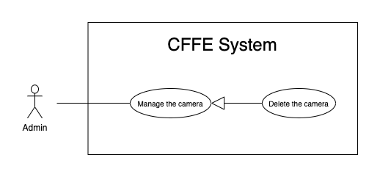

*Figure 29 - <Use Case> Delete the camera*

|  |  |  |  |
| --- | --- | --- | --- |
| ID and Name: | **UC-41 Delete the camera** | | |
| Created By: | HuuDN | Date Created: | 10/05/2021 |
| Primary Actor: | Admin | Secondary Actors: | N/A |
| Description: | This feature allows Admin to delete the camera. | | |
| Trigger: | Admin sends a request to delete the camera. | | |
| Preconditions: | PRE-01. User has logged in the system as manager role.  PRE-02. Admin is on “Camera detail” page. | | |
| Post-conditions: | POST-01:   * Success: CFFE system shows success message and reloads "Camera Detail" page. * Fail: CFFE system shows error message. | | |
| Normal Flow: | **41.0 Delete the camera**   1. Admin focus on "Pending" button then clicks on "Inactive" button. 2. CFFE system shows delete popup with message: "Do you want to inactive this camera?" and required form:  * "Inactive reason": text area * "OK": button * "Cancel" button  1. Admin inputs the field. 2. Admin clicks on "OK" button. (Alternative 41.0, 41.1) 3. CFFE system validates the product. (Exception 41.0.E1, 41.0.E2, 41.0.E3) 4. CFFE system updates the camera's status and returns the success message (MSG-040). | | |
| Alternative Flows: | **41.0 Admin cancels the deleting process.**   1. Admin clicks on "Cancel" button. 2. CFFE system closes this popup and terminates this use case.   **41.1 Admin clicks outside of popup.**   1. Admin clicks outside of popup. 2. CFFE system closes this popup and terminates this use case. | | |
| Exceptions: | **41.0.E1 Camera does not exist**   1. CFFE system returns error message (MSG-020) and terminates this use case.   **41.0.E2 The camera is still on the shelf or stack.**   1. CFFE system shows error message (MSG-066) and terminates this use case.   **41.0.E3 Admin inputs the inactive reason fields that are not valid**   1. CFFE system returns error message (MSG-067) and terminates this use case. | | |
| Priority: | Medium | | |
| Frequency of Use: | Often | | |
| Business Rules: | BR-032, BR-033, BR-056, BR-058 | | |
| Other Information: | In case of internet connection failure, Admin cannot finish this use case properly. | | |
| Assumptions: | N/A | | |

*Table 24 - <Use Case> Delete the camera*

##### 2.2.3.18 <Admin> Create new camera

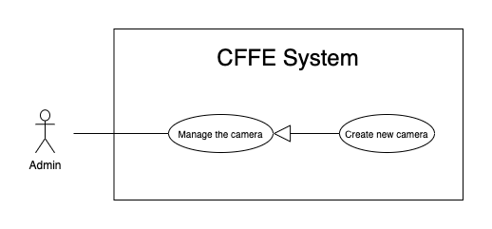

*Figure 30 - <Use Case> Create new camera*

|  |  |  |  |
| --- | --- | --- | --- |
| ID and Name: | **UC-42 Create new product** | | |
| Created By: | HuuDN | Date Created: | 10/05/2021 |
| Primary Actor: | Admin | Secondary Actors: | N/A |
| Description: | This feature allows Admin to create new camera. | | |
| Trigger: | Admin sends a request to create new camera. | | |
| Preconditions: | PRE-01. User has logged in the system as Admin role.  PRE-02. Admin is on “Camera” page. | | |
| Post-conditions: | POST-01:   * Success: CFFE system shows success message and reloads "Camera" page. * Fail: CFFE system shows error message. | | |
| Normal Flow: | **42.0 Create new camera**   1. Admin clicks on "New" to create new camera. 2. CFFE system shows creating camera popup that includes:    * "Image" button    * "Camera name": input text    * "IP address": input text    * "MAC address": input text    * "RPST string": input text    * "Type detect": radio button    * "Create": button    * "Cancel": button 3. Admin inputs/selects the required fields. 4. Admin clicks on the "Create" button to create new camera. 5. CFFE system validates the required fields (Exception 42.0.E1, 42.0.E2). 6. CFFE system stores newly created camera information and returns the success message (MSG-011). | | |
| Alternative Flows: | **42.0 Admin cancels the creating process.**   1. Admin clicks on "Cancel" button. 2. CFFE system closes this popup and terminates this use case.   **42.1 Admin clicks outside of popup.**   1. Admin clicks outside of popup. 2. CFFE system closes this popup and terminates this use case. | | |
| Exceptions: | **42.0.E1 Admin does not input/select the required fields**   1. CFFE system returns to Admin to input/select the required fields again (MSG-031, MSG-030, MSG-082, MSG-125). 2. If Admin inputs/selects the required fields again, CFFE system returns to step 3 of the normal flow. 3. Else if Admin cancels the creating process, then CFFE system terminates this use case.   **42.0.E1 Admin inputs/selects the fields that are not valid**   1. CFFE system returns to Admin to input/select the fields again (MSG-032, MSG-059, MSG-083, MSG-084, MSG-126). 2. If Admin inputs/selects the fields again, CFFE system returns to step 3 of the normal flow. 3. Else if Admin cancels the creating process, then CFFE system terminates this use case. | | |
| Priority: | Medium | | |
| Frequency of Use: | Often | | |
| Business Rules: | BR-035, BR-055, BR-056, BR-070 | | |
| Other Information: | In case of internet connection failure, Admin cannot finish this use case properly. | | |
| Assumptions: | N/A | | |

*Table 30 - <Use Case> Create new camera*

##### 2.2.3.19 <Admin> Update the category

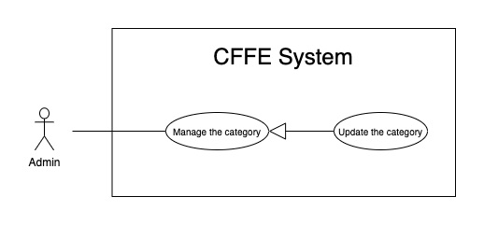

*Figure 33 - <Use Case> Update the category*

|  |  |  |  |
| --- | --- | --- | --- |
| ID and Name: | **UC-43 Update the category** | | |
| Created By: | HuuDN | Date Created: | 18/06/2021 |
| Primary Actor: | Admin | Secondary Actors: | N/A |
| Description: | This feature allows Admin to update category in CFFE system. | | |
| Trigger: | Admin sends a request to update the category. | | |
| Preconditions: | PRE-01. User has logged in the system as Admin role.  PRE-02. Admin is on “Category” page. | | |
| Post-conditions: | POST-01:   * Success: CFFE system shows success message and reloads "Category" page. * Fail: CFFE system shows error message. | | |
| Normal Flow: | **43.0 Update the category** (Alternative 43.0)   1. Admin clicks on "Edit information" to update category information. 2. CFFE system requires category information that includes:  * “Category name”: input text * “OK”: button * “Cancel”: button  1. Admin inputs the required fields. 2. Admin clicks on “Update” button. (Alternative 43.1) 3. CFFE system validates the fields (Exception 43.0.E1, 43.0.E2, 43.0.E3) 4. CFFE system updates camera information and returns the success message (MSG-013). | | |
| Alternative Flows: | **43.0 Reactivate the inactive camera.**   1. Admin focus on "Inactive" button then clicks on "Active" button. 2. CFFE system shows confirm popup with message "Do you want to active this category?" and two buttons for Admin selecting:    * "OK": button    * "Cancel": button 3. Admin clicks on "OK" button. (Alternative 43.1, 43.2) 4. CFFE system validates the camera. (Exception 43.0.E3) 5. CFFE system updates the camera's status and returns the success message (MSG-013).   **43.1 Admin cancels the updating process.**   1. Admin clicks on "Cancel" button. 2. CFFE system closes this popup and terminates this use case.   **43.2 Admin clicks outside of popup.**   1. Admin clicks outside of popup. 2. CFFE system closes this popup and terminates this use case. | | |
| Exceptions: | **43.0.E1 Admin does not input the required fields**   1. CFFE system returns to Admin to input/select the required fields again (MSG-105). 2. If Admin inputs the required fields again, CFFE system returns to step 3 of the normal flow. 3. Else if Admin cancels the login process, then CFFE system terminates this use case.   **43.0.E2 Admin inputs the fields that are not valid**   1. CFFE system returns to Admin to input/select the fields again (MSG-059, MSG-050). 2. If Admin inputs the fields again, CFFE system returns to step 3 of the normal flow. 3. Else if Admin cancels the login process, then CFFE system terminates this use case.   **43.0.E3 Category does not exist.**   1. CFFE system returns error message (MSG-029) and terminates this use case. | | |
| Priority: | Medium | | |
| Frequency of Use: | Often | | |
| Business Rules: | BR-032, BR-063 | | |
| Other Information: | In case of internet connection failure, Admin cannot finish this use case properly. | | |
| Assumptions: | N/A | | |

*Table 33 - <Use Case> Update the category*

##### 2.2.3.20 <Admin> Delete the category

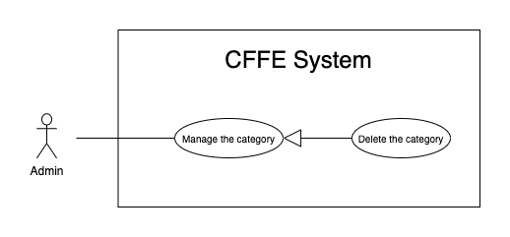

*Figure 33 - <Use Case> Update the category*

|  |  |  |  |
| --- | --- | --- | --- |
| ID and Name: | **UC-44 Delete the category** | | |
| Created By: | HuuDN | Date Created: | 18/06/2021 |
| Primary Actor: | Admin | Secondary Actors: | N/A |
| Description: | This feature allows Admin to delete category in CFFE system. | | |
| Trigger: | Admin sends a request to delete the category. | | |
| Preconditions: | PRE-01. User has logged in the system as Admin role.  PRE-02. Admin is on “Category” page. | | |
| Post-conditions: | POST-01:   * Success: CFFE system shows success message and reloads "Category" page. * Fail: CFFE system shows error message. | | |
| Normal Flow: | **44.0 Delete the category**   1. Admin focus on "Active" button then clicks on "Inactive" button. 2. CFFE system shows confirm popup with message: "Do you want to inactive this category?" and two buttons for Admin selecting:  * "OK": button * "Cancel" button  1. Admin clicks on "OK" button. (Alternative 41.0, 40.1) 2. CFFE system validates the product. (Exception 41.0.E1, 41.0.E2) 3. CFFE system updates the camera's status and returns the success message (MSG-013). | | |
| Alternative Flows: | **44.0 Admin cancels the deleting process.**   1. Admin clicks on "Cancel" button. 2. CFFE system closes this popup and terminates this use case.   **44.1 Admin clicks outside of popup.**   1. Admin clicks outside of popup. 2. CFFE system closes this popup and terminates this use case. | | |
| Exceptions: | **44.0.E1 Category does not exist**   1. CFFE system returns error message (MSG-029) and terminates this use case.   **44.0.E2 Category has a product.**   1. CFFE system shows error message (MSG-066) and terminates this use case. | | |
| Priority: | Medium | | |
| Frequency of Use: | Often | | |
| Business Rules: | BR-057 | | |
| Other Information: | In case of internet connection failure, Admin cannot finish this use case properly. | | |
| Assumptions: | N/A | | |

*Table 33 - <Use Case> Update the category*

##### 2.2.3.21 <Admin> Create new category

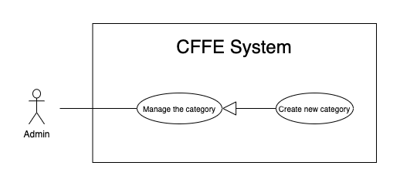

*Figure 35 - <Use Case> Create new category*

|  |  |  |  |
| --- | --- | --- | --- |
| ID and Name: | **UC-45 Create new category** | | |
| Created By: | TruongTN | Date Created: | 10/05/2021 |
| Primary Actor: | Admin | Secondary Actors: | N/A |
| Description: | This feature allows Admin to create new category. | | |
| Trigger: | Admin sends a request to create new category. | | |
| Preconditions: | PRE-01. User has logged in the system as Admin role.  PRE-02. Admin is on “Category” page. | | |
| Post-conditions: | POST-01:   * Success: CFFE system shows success message and reloads "Category" page. * Fail: CFFE system shows error message. | | |
| Normal Flow: | **45.0 Create new category**   1. Admin clicks on "New" to create new category. 2. CFFE system shows creating category popup that includes:    * "Camera name": input text 3. Admin inputs the required fields. 4. Admin clicks on the "Create" button to create new category. (Alternative 45.0, 45.1) 5. CFFE system validates the required fields (Exception 42.0.E1, 42.0.E2). 6. CFFE system stores newly created category information and returns the success message (MSG-011). | | |
| Alternative Flows: | **45.0 Admin cancels the creating process.**   1. Admin clicks on "Cancel" button. 2. CFFE system closes this popup and terminates this use case.   **45.1 Admin clicks outside of popup.**   1. Admin clicks outside of popup. 2. CFFE system closes this popup and terminates this use case. | | |
| Exceptions: | **45.0.E1 Admin does not input the required fields**   1. CFFE system returns to Admin to input the required fields again (MSG-105). 2. If Admin inputs the required fields again, CFFE system returns to step 3 of the normal flow. 3. Else if Admin cancels the creating process, then CFFE system terminates this use case.   **45.0.E1 Admin inputs the fields that are not valid**   1. CFFE system returns to Admin to input the fields again (MSG-059, MSG-050). 2. If Admin inputs the fields again, CFFE system returns to step 3 of the normal flow. 3. Else if Admin cancels the creating process, then CFFE system terminates this use case. | | |
| Priority: | Medium | | |
| Frequency of Use: | Often | | |
| Business Rules: | BR-063 | | |
| Other Information: | In case of internet connection failure, Admin cannot finish this use case properly. | | |
| Assumptions: | N/A | | |

*Table 31 - <Use Case> Create new category*

#### 2.2.5 <System AI> Overview Use Case

*Figure 2 - <Overview Use Case> System AI*

##### 2.2.5.1 <System AI> Analyze facial emotion

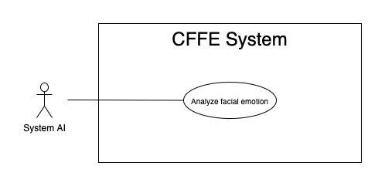

*Figure 3 - <Use Case> Analyze facial emotion*

|  |  |  |  |
| --- | --- | --- | --- |
| ID and Name: | **UC-46 Analyze facial emotion** | | |
| Created By: | HieuHD | Date Created: | 25/06/2021 |
| Primary Actor: | System AI | Secondary Actors: | N/A |
| Description: | This feature allows the System AI to analyze facial emotions. | | |
| Trigger: | When system is received a request to analyse video. | | |
| Pre-conditions: | PRE-01. Manager uploads the video successfully.  PRE-02. Uploaded videos are emotion type. | | |
| Post-conditions: | POST-01:   * Success: CFFE system shows complete notification and stores the detected videos and result. * Fail: CFFE system shows error message. | | |
| Normal Flow: | **46.0 Analyze facial emotion**   1. System AI detects the videos base on video type. 2. CFFE system shows "Detecting" notification during the detection process. 3. System AI sends the complete notification with success and error videos, detection result. 4. CFFE system shows "Complete" notification and stores the detected videos and result. | | |
| Alternative Flows: | N/A | | |
| Exceptions: | N/A | | |
| Priority: | High | | |
| Frequency of Use: | Always | | |
| Business Rules: | N/A | | |
| Other Information: | In case of internet connection failure, System AI cannot finish this use case. | | |
| Assumptions: | N/A | | |

*Table 4 - <Use Case> Analyze facial emotion*

##### 2.2.5.2 <System AI> Count the customers

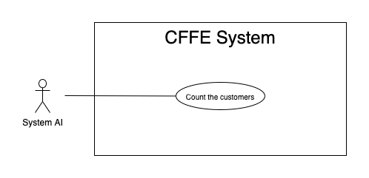

*Figure 3 - <Use Case> Count the customers*

|  |  |  |  |
| --- | --- | --- | --- |
| ID and Name: | **UC-47 Count the costumers** | | |
| Created By: | HieuHD | Date Created: | 25/06/2021 |
| Primary Actor: | System AI | Secondary Actors: | N/A |
| Description: | This feature allows the System AI to count the customers. | | |
| Trigger: | When system is received a request analyze videos. | | |
| Pre-conditions: | PRE-01. Manager uploads the videos successfully.  PRE-02. Uploaded videos are counting type. | | |
| Post-conditions: | POST-01:   * Success: CFFE system shows complete notification and stores the detected videos and result. * Fail: CFFE system shows error message. | | |
| Normal Flow: | **47.0 Count the customers**   1. System AI detects the videos base on video type. 2. CFFE system shows "Detecting" notification during the detection process. 3. System AI sends the complete notification with success and error videos, detection result. 4. CFFE system shows "Complete" notification and stores the detected videos and result. | | |
| Alternative Flows: | N/A | | |
| Exceptions: | N/A | | |
| Priority: | High | | |
| Frequency of Use: | Always | | |
| Business Rules: | N/A | | |
| Other Information: | In case of internet connection failure, System AI cannot finish this use case. | | |
| Assumptions: | N/A | | |

*Table 4 - <Use Case> Statistics number of customers*

## 3. Other Requirements

### 3.1 Messages List

|  |  |  |  |  |
| --- | --- | --- | --- | --- |
| **No** | **Message code** | **Message Type** | **Context** | **Content** |
| 1 | MSG-001 | Toast message | Username is empty | Username is required |
| 2 | MSG-002 | Toast message | Password is empty | Password is required |
| 3 | MSG-003 | Toast message | Login with invalid username or password | Invalid username or password |
| 4 | MSG-004 | Toast message | Old password is empty | Old password is required |
| 5 | MSG-005 | Toast message | New password is empty | New password is required |
| 6 | MSG-006 | Toast message | Retype password is empty | Retype password is required |
| 7 | MSG-007 | Toast message | New password and Retype password is not matched | New password and retype password must be matched |
| 8 | MSG-008 | Toast message | The password is not following format:  - At least one digit. - At least one lowercase character. - At least one uppercase character. - At least one special character. - At least 8 characters and a maximum of 20 characters. | The password format is wrong |
| 9 | MSG-009 | Toast message | The list has no data | No data |
| 10 | MSG-010 | Toast message | Uploading video is successful | Videos upload is successful! |
| 11 | MSG-011 | Toast message | Creating objects process is successful | Creating process is successful |
| 12 | MSG-012 | Toast message | The shelf doesn't exist | This shelf doesn't exist |
| 13 | MSG-013 | Toast message | Updating objects process is successful | Updating process is successful |
| 14 | MSG-014 | Toast message | Full name is empty | The full name is required |
| 15 | MSG-015 | Toast message | Full name is not between 1 to 100 characters | The full name is between 1 to 100 characters |
| 16 | MSG-016 | Toast message | Description is empty | The description is required |
| 17 | MSG-017 | Toast message | Description is not between 1 to 250 characters | The description is between 1 to 250 characters |
| 18 | MSG-018 | Toast message | Number of stacks is empty | The shelf's number of stacks is required |
| 19 | MSG-019 | Toast message | Number of stacks is not between 1 to 30 stacks | The shelf's number of stacks is between 1 to 30 stacks |
| 20 | MSG-020 | Toast message | The camera doesn't exist in CFFE system. | This camera doesn't exist |
| 21 | MSG-021 | Toast message | Deleting objects process is successful | Deleting process is successful |
| 22 | MSG-022 | Toast message | The stack doesn't exist in CFFE system | This stack doesn't exist |
| 23 | MSG-023 | Toast message | The product doesn't exist in CFFE system | This product doesn't exist |
| 24 | MSG-024 | Toast message | The camera id is empty | The camera id is required |
| 25 | MSG-025 | Toast message | The shelf has number of stacks is maximum | This shelf is full |
| 26 | MSG-026 | Toast message | The image is empty | Image is required |
| 27 | MSG-027 | Toast message | The image is not png, jpg, jpeg format | The image must be png, jpg, jpeg format |
| 28 | MSG-028 | Toast message | The category is empty | Category is required |
| 29 | MSG-029 | Toast message | The category does not exist | Category does not exist |
| 30 | MSG-030 | Toast message | The RTSP is empty | The RTSP string is required |
| 31 | MSG-031 | Toast message | The IP address is empty | The IP address is required |
| 32 | MSG-032 | Toast message | The IP address is wrong format | The IP address must be x.x.x.x format (x is number between 0 to 255) |
| 33 | MSG-033 | Toast message | The category doesn't exist | The category doesn't exist |
| 34 | MSG-034 | Toast message | The name already exists | The name already exists |
| 35 | MSG-035 | Toast message | The store doesn't exist | The store doesn't exist |
| 36 | MSG-036 | Toast message | The address is empty | Address is required |
| 37 | MSG-037 | Toast message | Address is not between 1 to 250 characters | Address is between 1 to 250 characters |
| 38 | MSG-038 | Toast message | City has not been selected | City is required |
| 39 | MSG-039 | Toast message | District has not been selected | District is required |
| 40 | MSG-040 | Toast message | Deleting object process is successful | Deleting process is successful |
| 41 | MSG-041 | Toast message | The manager doesn't exist | The user doesn't exist |
| 42 | MSG-042 | Toast message | Phone number is not between 10 to 13 digits | Phone is between 10 to 13 digits |
| 43 | MSG-043 | Toast message | Manager already exists | Manager already exists |
| 44 | MSG-044 | Toast message | Email is empty | Email is required |
| 45 | MSG-045 | Toast message | Email does not match /^(([^<>()[\]\\.,;:\s@"]+(\.[^<>()[\]\\.,;:\s@"]+)*)|(".+"))@((\[[0-9]{1,3}\.[0-9]{1,3}\.[0-9]{1,3}\.[0-9]{1,3}\])|(([a-zA-Z\-0-9]+\.)+[a-zA-Z]{2,}))$/ regex | Email is wrong format |
| 46 | MSG-046 | Toast message | Status doesn't exist | Status doesn't exist |
| 47 | MSG-047 | Toast message | Birthdate is empty | Birthdate is required |
| 48 | MSG-048 | Toast message | Birthdate is greater than current date. | Birthdate is invalid |
| 49 | MSG-049 | Toast message | Phone is empty | Phone is required |
| 50 | MSG-050 | Toast message | Category name is not between 1 to 100 characters | Category name is between 1 to 100 characters |
| 51 | MSG-051 | Toast message | Identity card is empty | Identity card is required |
| 52 | MSG-052 | Toast message | Identity card does not include from 9 to 12 digits | Identity card includes from 9 to 12 digits |
| 53 | MSG-053 | Toast message | Password is wrong | Password is wrong |
| 54 | MSG-054 | Toast message | Gender is not selected | Gender is required |
| 55 | MSG-055 | Toast message | Email exists. | Email already exists |
| 56 | MSG-056 | Toast message | Identify card is exist | Identify card already exists |
| 57 | MSG-057 | Toast message | IP address exists | IP address already exists |
| 58 | MSG-058 | Toast message | RTSP String exists | RTSP string already exists |
| 59 | MSG-059 | Toast message | Category name exists | Category name already exists |
| 60 | MSG-060 | Toast message | Product name exists | ProductName already exists |
| 61 | MSG-061 | Toast message | Shelf name exists | Shelf name already exists |
| 62 | MSG-062 | Toast message | Store name exists | Store name already exists |
| 63 | MSG-063 | Toast message | The manager is not found. | The manager is not found |
| 64 | MSG-064 | Toast message | Create manager successfully. | Create manager successfully |
| 65 | MSG-065 | Toast message | This status does not exist. | This status does not exist |
| 66 | MSG-066 | Toast message | Pending status can be changed to be inactive status if it has an inactive reason and mappings are inactive.  Inactive status only changing to be pending status. | Changing status fail |
| 67 | MSG-067 | Toast message | Inactive reason is not from 1 to 250 characters. | Inactive reason must be from 1 to 250 characters |
| 68 | MSG-068 | Toast message | The old password is not correct. | The old password is not correct |
| 69 | MSG-069 | Toast message | Store ID cannot empty. | Store ID is required |
| 70 | MSG-070 | Toast message | Analyzed time cannot empty. | Analyzed time is required |
| 71 | MSG-071 | Toast message | Shelf Id cannot empty when get shelf detail | Shelf Id is required |
| 72 | MSG-072 | Toast message | Wrong time format (hh:mm:ss) | Time must be format (hh:mm:ss) |
| 73 | MSG-073 | Toast message | Birthday is not YYYY-MM-DD format | Birthday must be followed by YYYY-MM-DD format |
| 74 | MSG-074 | Toast message | Manager is not found  Manager status is not pending | Manager is not available |
| 75 | MSG-075 | Toast message | Store is not found Store status is not pending | Store is not available |
| 76 | MSG-076 | Toast message | System cannot finish this action | System cannot finish this action |
| 77 | MSG-077 | Toast message | Store and Manager is not mapping | Store and Manager is not mapping |
| 78 | MSG-078 | Toast message | Stack ID is empty | Stack ID is required |
| 79 | MSG-079 | Toast message | Shelf name is empty | Shelf name is required |
| 80 | MSG-080 | Toast message | Shelf name is not from 1 to 100 characters. | Shelf name must be from 1 to 100 characters |
| 81 | MSG-081 | Toast message | Store contain shelfs active or pending. | Store contain shelves active or pending |
| 82 | MSG-082 | Toast message | Camera name cannot be empty | Camera name is required |
| 83 | MSG-083 | Toast message | Camera name is not from 1 to 100 characters. | Camera name must be from 1 to 100 characters |
| 84 | MSG-084 | Toast message | Type detect is not 1 or 2. | Type detect is not exist |
| 85 | MSG-085 | Toast message | Shelf must be existed and not active. | Shelf must be existed |
| 86 | MSG-086 | Toast message | Camera must be existed and not active. | Camera must be existed and not active |
| 87 | MSG-087 | Toast message | Camera or Shelf is not available. | Camera or Shelf is not available |
| 88 | MSG-088 | Toast message | Shelf and Camera is not mapping | Shelf and Camera is not mapping |
| 89 | MSG-089 | Toast message | Product is not active. | Product is not active |
| 90 | MSG-090 | Toast message | Stack's status is active or inactive. | Stack is already active or inactive |
| 91 | MSG-091 | Toast message | Stack already has a product. | Stack already has a product |
| 92 | MSG-092 | Toast message | Product and Stack is not mapping. | Product and Stack is not mapping or stack already has camera |
| 93 | MSG-093 | Toast message | Camera is already active or inactive. | Camera is already active or inactive |
| 94 | MSG-094 | Toast message | Camera and Stack is not mapping. | Camera and Stack is not mapping |
| 95 | MSG-095 | Toast message | Stack contain product. | Stack contain product |
| 96 | MSG-096 | Toast message | Product ID is required. | Product ID is required |
| 97 | MSG-097 | Toast message | Have stack contain this product. | Have stack contain this product |
| 98 | MSG-098 | Toast message | Active status can be changed to be inactive status if it has an inactive reason, and no any stack contain it. | Changing status fail |
| 99 | MSG-099 | Toast message | Product name is required. | Product name is required |
| 100 | MSG-100 | Toast message | Stack much contain product. | Stack must contain product |
| 101 | MSG-101 | Toast message | Stack already active. | Stack already active |
| 102 | MSG-102 | Toast message | Category is required. | Category is required |
| 103 | MSG-103 | Toast message | Product does not belong 1 - 3 categories | Category list at least 1 item, and maximum is 3 |
| 104 | MSG-104 | Toast message | Category list contain invalid id. | Category list contain invalid id |
| 105 | MSG-105 | Toast message | Category name is required. | Category name is required |
| 106 | MSG-106 | Toast message | Store name is required. | Store name is required |
| 107 | MSG-107 | Toast message | Store address is required. | Store address is required |
| 108 | MSG-108 | Toast message | Store analysed time is required. | Store analyzed time is required |
| 109 | MSG-109 | Toast message | This category is being used. | This category is being used |
| 110 | MSG-110 | Toast message | Active status can be changed to be inactive status if it has no product using it | Changing status fail |
| 111 | MSG-111 | Toast message | System have some problem | System have some problem Please try later |
| 112 | MSG-112 | Toast message | Don't select the image to change image | Please select an image |
| 113 | MSG-113 | Toast message | Image is not jpg, jpeg, png format. | jpg/jpeg/png file types are supported |
| 114 | MSG-114 | Toast message | System upload video to storage fail. | System could not create the directory where the uploaded files will be stored in server |
| 115 | MSG-115 | Toast message | End date is empty | End date is required |
| 116 | MSG-116 | Toast message | Choose End date greater than Start date | End date need to greater than Start date |
| 117 | MSG-117 | Toast message | Date is wrong format | Date must be followed by format YYY-MM-dd |
| 118 | MSG-118 | Toast message | Uploading videos is not mp4 format | Mp4 file type is supported |
| 119 | MSG-119 | Toast message | Don't select the video to upload | Please select a video |
| 120 | MSG-120 | Toast message | Access to URL is not permission | You have no permission to access |
| 121 | MSG-121 | Toast message | Uploading videos is wrong name format | There are at least 1 video have invalid name |
| 122 | MSG-122 | Toast message | Uploading videos don't belong to any store's cameras | There are at least 1 video does not map with camera |
| 123 | MSG-123 | Toast message | Uploading videos are duplicated | There are at least 1 video duplicated |
| 124 | MSG-124 | Toast message | Sending email for the manager is failed | Sending email fail |
| 125 | MSG-125 | Toast message | MAC address is empty | MAC address is required |
| 126 | MSG-126 | Toast message | MAC address is wrong format | MAC address must contain 12 hexadecimal digits (XX-XX-XX-XX-XX-XX) |
| 127 | MSG-127 | Toast message | MAC address exists in CFFE system | MAC address already exists |
| 128 | MSG-128 | Toast message | The number of cameras added to the shelf exceeds 2 | The maximum camera on the shelf is 2 |
| 129 | MSG-129 | Toast message | Store name is between 1 to 100 characters | Store name is between 1 to 100 characters. |
| 130 | MSG-130 | Toast message | Product name is not between 1 to 100 characters | Product name is between 1 to 100 characters. |

# IV. Software Design Description

**5. Algorithms & Research**

**5.1 Detect emotion**

**a. Problem definition**

Import a video and recognize all faces which appear in the video then emotion classification based on facial expression.

**b. Requirement**

* Almost all faces have been successfully identified.
* Emotion classification has the least error.

**c. Solution**

* We use machine learning to recognize faces and classify emotions. We choose two models: MTCNN (face recognition) and VGG-Face (emotion classification).
* Advantages of MTCNN: using Deep Learning to recognize faces, high accuracy.
* Advantages of VGG-Face: using Deep Learning to emotions classification, high accuracy.

**Base Concept**

1. **CNN Architecture**

The CNN architecture is one of the advanced Deep Learning architectures, it simulates how the human brain works through neural neurons to perform some human ability. This architecture is widely used in image recognition with extremely high accuracy. Below is a basic CNN architecture with three main layers that are convolution, pooling, and fully-connected.

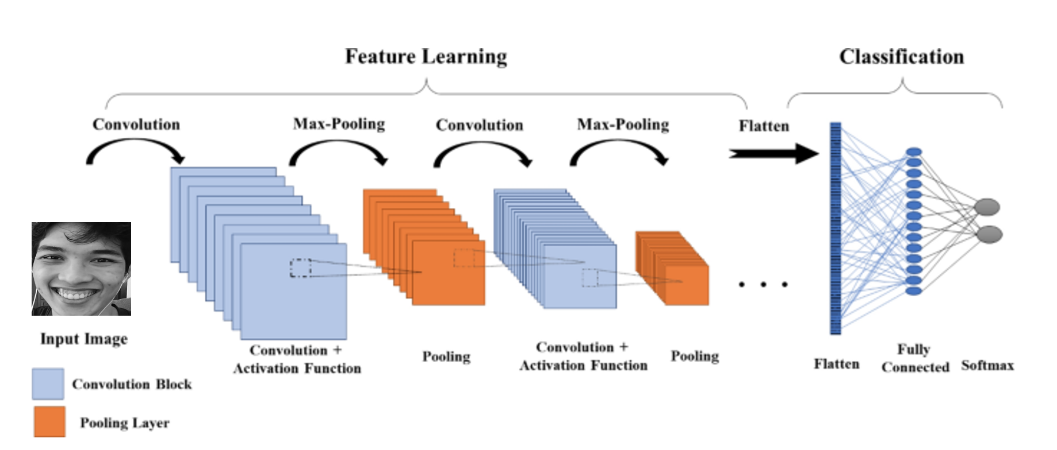

*Figure: CNN architecture*

* Convolutional Layer: extracts critical features from input images by filter matrix.

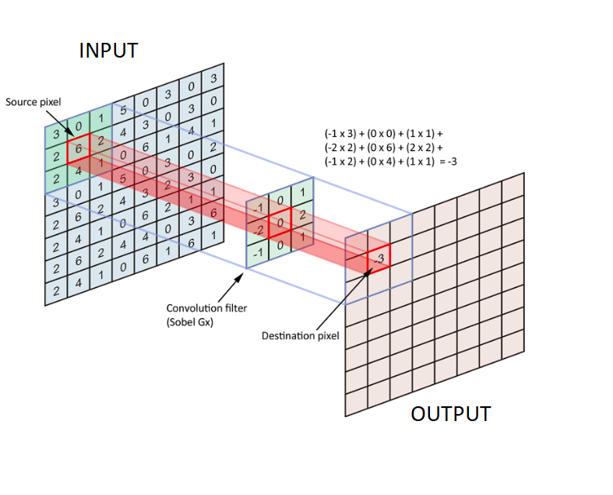

*Figure: Extracting critical features in convolution layer*

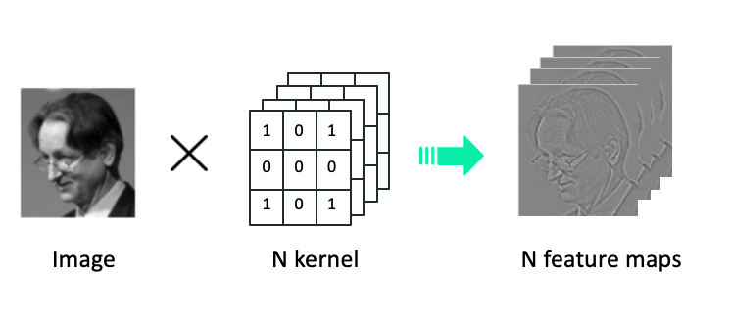

*Figure: Convolution example in process*

* Pooling layer: provides an approach to down sampling of features to reduces the number of learning parameters and the amount of computation performed in the network.

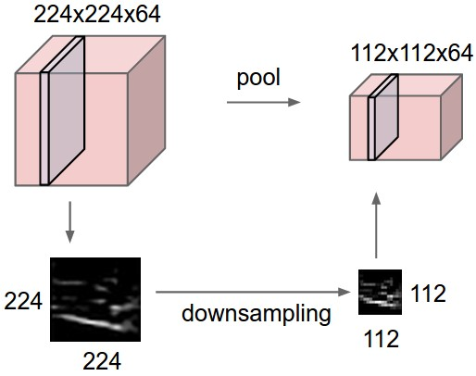

*Figure: Pooling example in process*

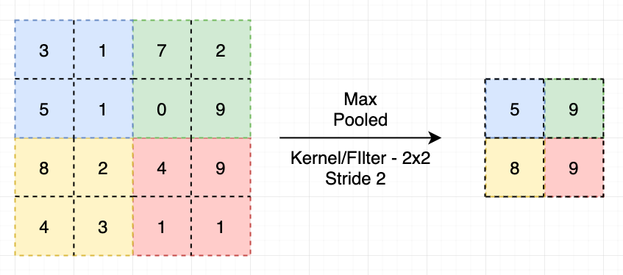

*Figure: Max pooling*

* Fully-connected layer: The feature maps will be flattened by converting the feature maps to vectors before entering the Fully connected layer. The purpose of this class is to combine the features of an image and produce an output.

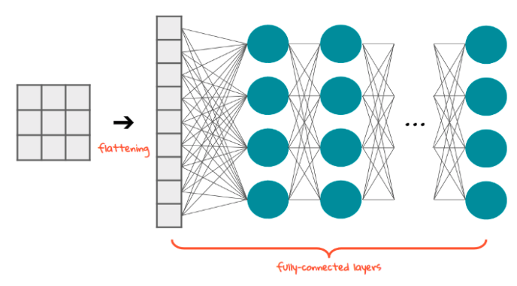

*Figure: Fully-conected example in process*

In Convolution and Fully-connected layers, several activation functions are often applied with different purposes.

* ReLU (Rectified Linear Unit): removes negative values on feature maps and return those values to 0, these are the parts that do not match the characteristics of the recognized object or in other words remove the neurons that are no longer active.

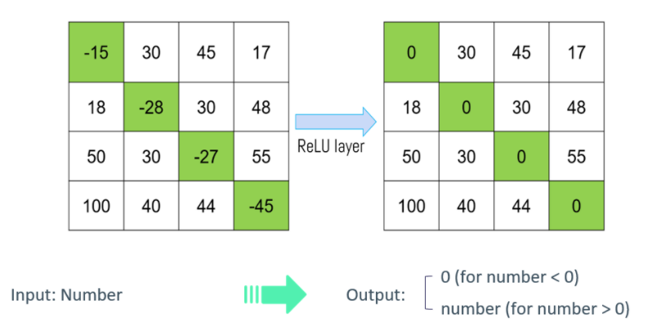

*Figure: ReLU example in process*

* Softmax: converts the actual values in the nodes in the output layer to the percentage value with which the predicted probability corresponds to the label.

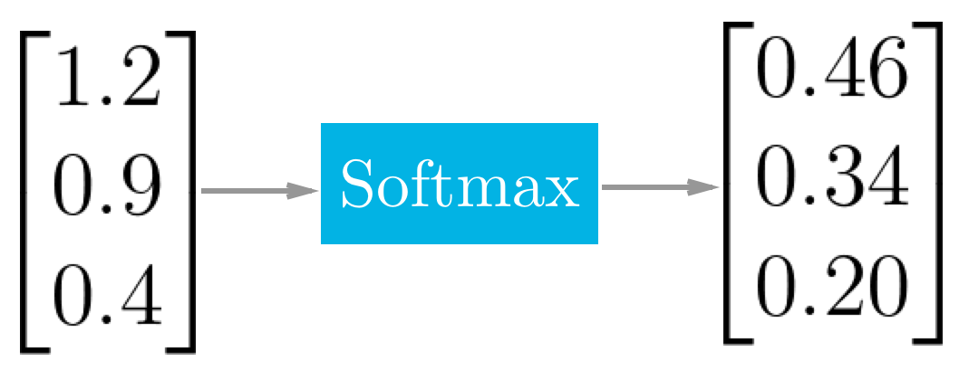

*Figure: Softmax example in process*

1. **MTCNN Architecture**

MTCNN (Layered Multitasking Network) architecture consists of three CNNs stacked on top of each other: P-NET (Recommended Network), R-NET (Tune Network), O-NET (Output Network).

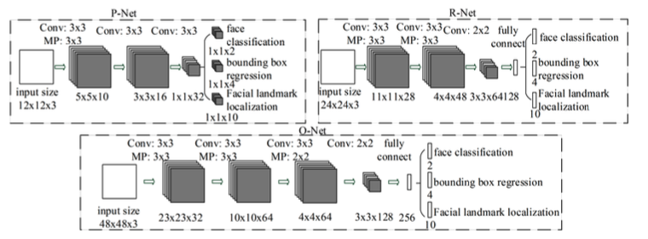

*Figure: MTCNN architecture*

The first step is to take the image and resize it to different scales in order to build an image pyramid, which is the input of the following three-stage cascaded network.

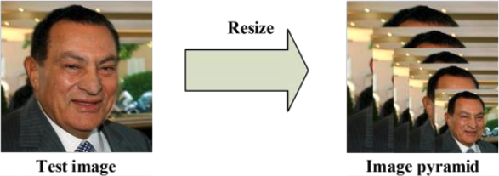

*Figure: Resizing image*

* Stage 1: Feeding the image into P-Net are obtain candidate windows and their bounding box regression vectors. Then using estimated bounding box regression vectors to calibrate the candidates and use a non-maximum suppression (NMS) to merge highly duplicated candidates.

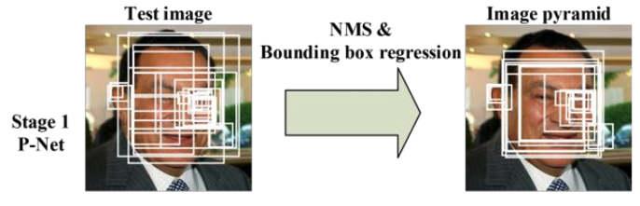

*Figure: Stage 1 example process*

* Stage 2: All candidates are fed to R-Net which further rejects a large number of false candidates, performs calibration with bounding box regression, and NMS candidate merge.

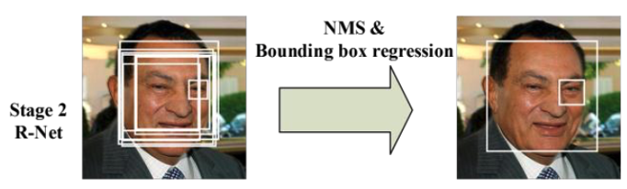

*Figure: Stage 2 example process*

* Stage 3: All candidates are fed to O-Net which aims to describe the face in more details.

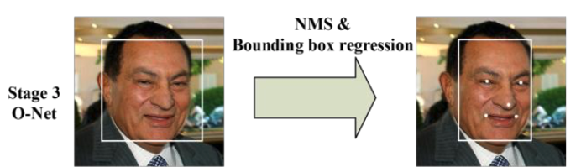

*Figure: Stage 3 example process*

1. **VGG-Face**

The VGG-Face using CNN implementation based on VGG-Very-Deep 16 (VGG-16) CNN architecture on the labelled faces in the Wild and the YouTube faces dataset. The purpose of the VGG-Face model is to recognize celebrities so for the purpose of classifying emotions by percentage, we modify the last layer to a fully-connected layer with softmax activation function.

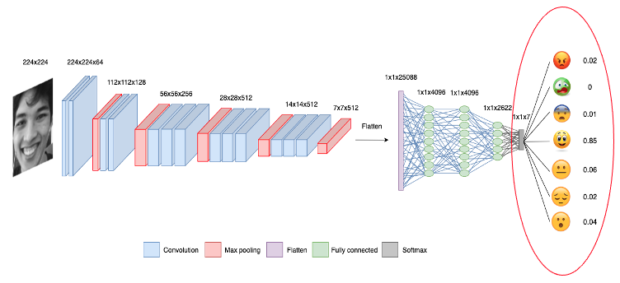

*Figure: Modified VGG-Face model architecture*

**Application**

CFFE system applies emotion classification including the following steps:

* Step 1: Read frames from an input video. However, human emotions change little across frames, so we only take certain frames for analysis.

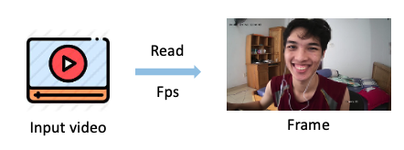

*Figure: Step 1 in emotion classification*

* Step 2: Feed frames into the MTCNN model for face recognition. We will remove faces with less than 95% accuracy.

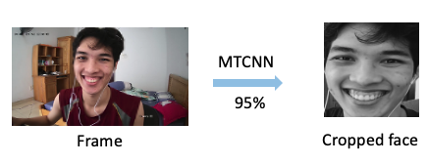

*Figure: Step 2 in emotion classification*

* Step 3: Feeding the remaining cropped face into the VGG-Face model to classify emotions according to the probability of each emotion label.

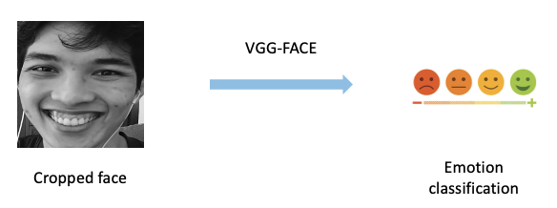

*Figure: Step 3 in emotion classification*

* Step 5: We will label emotion the perception by getting the highest prediction probability to compare with “confidence” variable (CFFE system is setting to 50%). Predictions that have probability less than "confidence" variable will be labelled "Unknown".

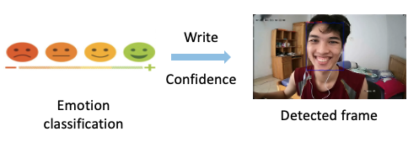

*Figure: Step 4 in emotion classification*

* Step 5: Save analyzed video and results.

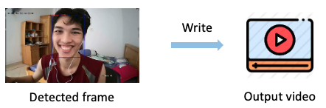

*Figure: Step 5 in emotion classification*

**Prepare data and train process**

* Data augmentation: Using methods such as flipping, increasing and decreasing the brightness, rotating, scaling ... before training model to increase the accuracy of the model's prediction under different conditions.

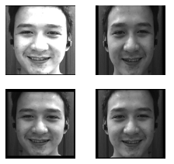

*Figure: Data augmentation*

* Dataset:
  + Data train: 28688 images (280 images of our members + Fer2013 dataset)
  + Data test: 7275 images (70 images of our members + FER2013 dataset)
* Train 32 epochs in 6 hours.
* Data features: An image contains 1 face corresponding to 7 types of emotions



*Figure: Single image*

##### Evaluate Model

* We evaluate model base on accuracy, loss.
* Accuracy: is the count of predictions where the predicted value is equal to the true value.
$$Accuracy = \frac{Number of correct predictions}{Total number of predictions}$$

* Loss: takes into account the probabilities or uncertainty of a prediction based on how much the prediction varies from the true value.

$$Loss = -\sum_{i=1}^{n}{\sum_{j=1}^{m}{y_{i,j}\log_{e}{(p_{i,j})}}}$$

In there,

$n$: Number of data points

$m$: Number of classes

$y_{i,j}$: Correct label

$p_{i,j}$: Prediction label

* Evaluate MTCNN mode

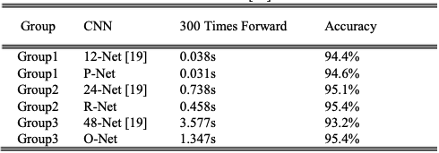

*Figure: Evaluate MTCNN model*

*Source:* [*https://arxiv.org/abs/1604.02878*](https://arxiv.org/abs/1604.02878)

MTCNN model contains 3 CNNs: P-Net, R-Net and O-Net. So its accuracy will be calculated as follows:

$$Accuracy of MTCNN model=94.6\% * 95.4\% * 95.4\% = 86.09\%$$

* Evaluate VGG-Face model

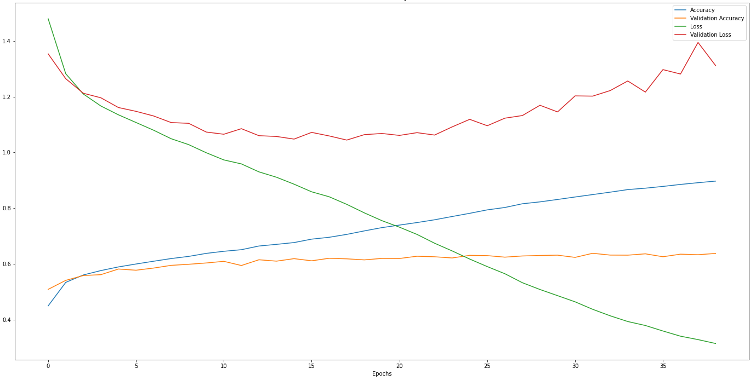

*Figure: Evaluate VGG-Face model*

Because during the training, the validation accuracy from the 32nd epoch onward does not increase anymore, so we using it as the weight to apply CFFE system. The result of the 32nd epoch is:

* + Accuracy: 84.89%
  + Loss: 0.4372
* Conclude: Emotion classification is dependent on 2 models: MTCNN and VGG-Face, so the accuracy is calculated as follows:

$$Accuracy=86.09\% * 84.89\% =73.08\%$$

The accuracy of our model is acceptable.